**National University of Ho Chi Minh City UNIVERSITY OF INFORMATION TECHNOLOGY**



**FINAL PROJECT REPORT**Subject : System Analysis and Design

Semester II (20212022)

**TOPIC:**

**LIBRARY MANAGEMENT SYSTEM**

**APPLICATION**

Student:

1. Nguyen Thi Cam Van *(Leader)* ID: 20522145
2. Luu Thao Linh ID: 20521532
3. Bui Quoc Thai ID 20521885
4. Tran Nhat Tan ID: 19522177

**Instructors: PhD. Cao Thị Nhạn, M.S. Dương Phi Long**

**Class: IS201.M21.HTCL**

HO CHI MINH CITY, June 2022

**National University of Ho Chi Minh City UNIVERSITY OF INFORMATION TECHNOLOGY**



**FINAL PROJECT REPORT**Subject : System Analysis and Design

Semester II (20212022)

**TOPIC:**

**LIBRARY MANAGEMENT SYSTEM**

**APPLICATION**

Student:

1. Nguyen Thi Cam Van *(Leader)* ID: 20522145
2. Luu Thao Linh ID: 20521532
3. Bui Quoc Thai ID 20521885
4. Tran Nhat Tan ID: 19522177

**Instructors: PhD. Cao Thị Nhạn, M.S. Dương Phi Long**

**Class: IS201.M21.HTCL**

HO CHI MINH CITY, June 2022

**TABLE OF CONTENTS**

**ACKNOWLEDGEMENT** 8

**TEACHER’S COMMENTS** 9

**CHAPTER 1 – INTRODUCTION** 10

**1.1 Problems** 10

**1.2 Project goal** 11

**1.3 Scope of project / Limitations of the study** 11

**1.4 Developer tools & Technology** 12

**CHAPTER 2 REQUIREMENTS DEFINITION AND ANALYSIS** 12

**2.1** **Situation survey/ Survey of current situation** 12

**2.1.1 Interview** 12

**2.2 Requirements definition** 20

**2.2.1 Function** 20

**2.2.2 Nonfunction** 21

**CHAPTER 3 ANALYSIS AND DESIGN SYSTEM** 22

**3.1 Problem specification** 22

**3.2 Usecase diagram** 25

**3.3 List of system actors** 27

**3.4 List of usecase** 28

**3.5 Usecase specification and activity diagram** 29

**3.5.1 Sign in usecase** 29

**3.5.2 Book tittle management usecase** 30

**3.5.2.1** **Display titles** 30

**3.5.2.2** **Insert Title** 33

**3.5.2.3** **Update Title** 34

**3.5.2.4** **Delete Title** 35

**3.5.2.5** **Search Title** 36

**3.5.2.6** **Add Book** 37

**3.5.3 Manage Reader** 38

**3.5.3.1 Display Reader** 39

**3.5.3.2 Insert Reader** 40

**3.5.3.3 Update Reader** 41

**3.5.3.4 Delete Reader** 42

**3.5.3.5 Search Reader** 43

**3.5.4 Look Up Book Status** 44

**3.5.5 Manage The Process Of Borrowing Books** 45

**3.5.5.1 Display Call Card** 46

**3.5.5.2 Insert Call Card** 47

**3.5.5.3 Update Call Card** 48

**3.5.5.4 Delete Call Card** 49

**3.5.5.5 Search Call Card** 50

**3.5.5.6 Insert Borrow Books Details** 51

**3.5.6 Manage The Return Process** 52

**3.5.6.1 Display Return Card** 53

**3.5.6.2 Insert Return Card** 54

**3.5.6.3 Delete Return Card** 55

**3.5.6.4 Update Return Card** 56

**3.5.6.5 Search Return Card** 57

**3.5.6.6 Add Book Return Details** 58

**3.5.6.7 Add Fines Receipts** 59

**3.5.7 Statistic Report** 60

**3.6 Sequence Diagram** 62

**3.6.1 Sequence Login** 62

**3.6.2 Sequence Manage Reader** 63

**3.6.2.1 Display Reader** 63

**3.6.2.2 Search Reader** 64

**3.6.2.3 Insert Reader** 65

**3.6.2.4 Update Reader** 66

**3.6.2.5 Delete Reader** 67

**3.6.3 Sequence Manage Title** 68

**3.6.3.1 Display Title** 68

**3.6.3.2 Search Title** 69

**3.6.3.3 Insert Title** 70

**3.6.3.4 Update Title** 71

**3.6.3.5 Delete Title** 72

**3.6.3.6 Insert Book** 73

**3.6.4 Sequence Look up book status** 74

**3.6.5 Squence Manage the process of borrowing books** 75

**3.6.5.1 Search call card** 75

**3.6.5.2 Insert call card** 76

**3.6.5.3 Update call card** 77

**3.6.5.4 Delete call card** 78

**3.6.5.6 Insert borrow book details** 79

**3.6.6 Manage the Return Process** 80

**3.6.6.1 Display return card** 80

**3.6.6.2 Insert return card** 81

**3.6.6.3 Update return card** 82

**3.6.6.4 Delete return card** 83

**3.6.6.5 Search Return Card** 84

**3.6.6.6 Add Book Return Detail** 85

**3.6.6.7 Add Fines Receipts** 86

**3.6.7 Statistic Report** 87

**3.6** **Class Diagram 3.7.1 Adminstrator overview class diagram** 88

**3.7.1 Class Login** 89

**3.7.2 Class Look up book status** 90

**3.7.3 Class Manage Reader** 90

**3.7.4 Class Manage Title** 91

**3.7.5 Class Manage the process of borrowing books** 92

**3.7.6 Class Manage the return Process** 93

**3.8 State Diagram** 93

**3.9 Mapping to Relational Model from Entity class diagram** 93

**3.9.1 Description of ERD** 95

**3.1.2.1 Entity name: DOCGIA** 95

**3.9.1.2 Entity name: DAUSACH** 95

**3.9.1.3 Entity name: CUONSACH** 96

**3.9.1.4 Relation name: CTTS** 96

**3.9.1.5 Entity name: PHIEUMUONSACH** 97

**3.9.1.6 Entity name: PHIEUTRASACH** 97

**3.9.1.7 Entity name: HOADON** 97

**3.9.1.8 Relation name: CTMS** 98

**3.9.1.9 Relation name: Thuoc2** 98

**3.9.1.10 Name relation: Thuoc2** 98

**3.9.1.11 Relation name: Co** 98

**3.9.1.12 Relation name: Tontai** 98

**3.9.2 Convert the ERD to a physical data model** 99

**3.9.2.1 DAUSACH** 99

**3.9.2.2 CUONSACH** 100

**3.9.2.3 DOCGIA** 100

**3.9.2.4 PHIEUMUONSACH** 101

**3.9.2.5 CTMS** 101

**3.9.2.6 PHIEUTRASACH** 101

**3.9.2.7 CTTS** 102

**3.9.2.8 HOADON** 102

**CHAPTER 4: IMPLEMENTATION AND TESTING** 103

**4.1 Development environment** 103

**4.2 List of screens** 103

**4.2.1 Login** 103

**4.2.2 Library management** 103

**4.3 Description of screens** 105

**4.3.1 Login** 105

**4.3.2 Library management** 105

**4.3.2.1 Manage Reader** 106

**4.3.2.2 Manage Title** 107

**4.3.2.3 Book information** 108

**4.3.2.4 Manage Call Card** 110

**4.3.2.5 Call Card Detail** 111

**4.3.2.6 Manage Return Card** 112

**4.3.2.7 Return Card Detail** 114

**4.3.2.8 Invoice** 116

**4.3.2.9 Statistic report** 118

**CHAPTER 5 – CONCLUSION** 119

**5.1 Results achieved** 119

**5.2 Restrict** 120

**5.3 Lessons learned:** 121

**5.4 Evaluation of project results:** 121

**5.5 Direction of development:** 121

**REFERENCES:** 122

**The end.** 122

# **ACKNOWLEDGEMENT**

In fact, there is no success that is not tied to the support and help, whether more or less, directly or indirectly from others. With the deepest gratitude, first of all, our group would like to express our sincere thanks to the teachers of the University of Information Technology Vietnam National University, Ho Chi Minh City and the teachers of the Faculty of Information Systems helped the group to have the basic knowledge as a basis to carry out this topic.

In particular, our team would like to express our sincere thanks to Mrs. Cao Thi Nhan theoretical lecturer and Mr. Duong Phi Long practical lecturer of Systems Analysis and Design who wholeheartedly helped, directly instructed and guided the group throughout the process a project.

Thanks to that, we have gained a lot of useful knowledge in applying as well as projectmaking skills. Without the guidance and teachings of the teacher, our group thinks this project of the group would be very difficult to complete. Once again, I sincerely thank teacher. In addition, for the project to be completed, it is impossible to thank the people who did it, thank you to the team members who worked hard and completed the task on schedule.

Finally, thank you to all the team members who worked at their best to complete their thesis well. Sincerely thank!

# **TEACHER’S COMMENTS**

………………………………………………………………………………………………………………………………………………………………………………………………………………………………………………………………………………………………………………………………………………………………………………………………………………………………………………………………………………………………………………………………………………………………………………………………………………………………………………………………………………………………………………………………………………………………………………………………………………………………………………………………………………………………………………………………………………………………………………………………………………………………………………………………………………………………………………………………………………………………………………………………………………………………………………………………………………………………………………………………………………………………………………………………………………………………………………………………………………………………………………………………………………………………………………………………………………………………………………………………………………………………………………………………………………………………………………………………………………………………………………………………………………………………………………………………………………………………………………………………………………………………………………………………………………………………………………………………………………………………………………………………………………………………………………………………………………………………………………………………………………………………………………………………………………………………………………………………………………………………………………………………………………………………………………………………………………………………………………………………………………………………………………………………………………………………………………………………………………………………………………………………………………………………………………………………………………………………………………………………………………………………………………………………………………………………………………………………………………………………………………………………………………………………………………………………………………………………………………………………………………………………………………………………

# **CHAPTER 1 – INTRODUCTION**

## **1.1 Problems**

In today's era, information work in general and library information in particular have a special importance and profound influence on all areas of social life, including education and training. The effective exploitation of information has become one of the leading factors in the socioeconomic development strategy of any country. Therefore, the role of the library in schools as well as in the community has become increasingly important and essential. The library performs 4 basic functions, including: cultural function, information function, educational function and entertainment function within the scope of the school's operation and oriented towards serving the community in the area.

Currently, many schools are planning to apply information technology to library management, because manual recording is becoming inappropriate in the developing 4.0 technology era. If we keep recording the book borrowing/returning manually, it will cause to the checking of available/loaned books very time consuming and can cause errors. Therefore, the introduction of library management software to replace manual tools is essential. Management software helps to quickly look up available/loaned books of readers; easily add new books, store information on the database by software, convenient and accurate in statistics, and at the same time avoid data errors, minimize possible loss of money as well as property of the library.

In the research content of the project, the focus is limited to the management of the basic information of the system management software. The management is computerized with basic functions such as reader management, book management, loan management, payment management,... For other functions of the software, depending on the requirements and development environment of the customer, it is changed and developed accordingly.

## **1.2 Project goal**

From the actual analysis, it can be seen that the most effective solution for library management is management through software. Therefore, in the scope of this project, our team would like to create an application to help automate the library management

***For function:***

* Help managers and librarians easily manage books, book borrowing process, book return process and library bills
* Managers can statistic the status of books, borrowing status, fines for overdue return of books
* Helping readers find books in the library quickly and easily

***For interface***:

* Use multiple languages.
* Management interface is friendly, simple, easy to use, suitable for requirements
* Customize modification easily, high security

***For quality***

* Easily upgrade or increase utility modules.
* Works well with all popular web browsers today (Linux, Window, MacOs, ...)

## **1.3 Scope of project / Limitations of the study**

Due to time and people constraints, our team decided to focus on a few key features like:

* Reader card management
* Book titles management
* Book information management
* Call card management
* Book loan details management
* Statistical report

## **1.4 Developer tools & Technology**

* Git / GitHub for storing, tracking, and collaborating on software projects.
* Netbeans as code editor.
* Oracle as Model Component in MVC

# **CHAPTER 2 REQUIREMENTS DEFINITION AND ANALYSIS**

## **2.1** **Situation survey/ Survey of current situation**

## **2.1.1 Interview**

|  |  |  |  |  |
| --- | --- | --- | --- | --- |
| **General survey**  System:QLTV  Creator: Bui Quoc Thai   Created Date: 20/05/2032 | | | | |
| **ORD** | **TOPIC** | **REQUIREMENT** | **START** | **END** |
| 1 | System overview | Understand the purpose and effect of building a library management system | 08/05/2022 | 08/05/2022 |
| 2 | Manage book title information | Get the title information, book status. | 08/05/2022 | 08/05/2022 |
| 3 | Manage reader information | Understand the process of managing reader information. | 08/05/2022 | 08/05/2022 |
| 4 | Manage the process of borrowing books | Understand the book borrowing process and related procedures. | 08/05/2022 | 08/05/2022 |
| 5 | Manage the book return process | Understand the book return process and related procedures. | 08/05/2022 | 08/05/2022 |
| 6 | Manage the book import process | Understand the procedures in the book import process. | 08/05/2022 | 08/05/2022 |
| 7 | Report Statistic | Understand the reporting process. | 08/05/2022 | 08/05/2022 |
| 8 | Rules change | The important role  of the rule change  determined. | 08/05/2022 | 08/05/2022 |

|  |  |  |
| --- | --- | --- |
| **Survey Forms**  *System*: QLTV | | |
| *Interviewee:* Tran Nhat Tan | *Interviewer:* Bui Quoc Thai | |
| *Place:* QLTV | *Start:* 8:00 am 09/05/2021  End*:* 11:30 am 09/05/2021 | |
| *Target: Collect and understand the working process of libraries.* | |  |
| *Details of the interview:*   * *Introduction* * *Overview about current system* * *Survey plan:* * *Topic 1: The process of managing book title information* * *Topic 2: Process of managing reader information* * *Topic 3: Manage the process of borrowing books* * *Topic 4: Manage the book return process* * *Topic 5:*  *Statistical report* * *Topic 6: Changing regulations* | | *Estimated Time:*   * *5 mins* * *15 mins* * *30 mins* |
| *General Observe* | |  |
| *Unexpected occurrence* | |  |

|  |  |  |  |
| --- | --- | --- | --- |
| *Interviewee:* Luu Thao Linh | | 21/05/2021 | |
| *Questions* | | *Records* | |
| System overview | Manager wants to build a system based on the old system or a entirely new system? | Build a completely new library management system. | |
| Where will the system retrieve data from? | The data source is taken from the log book in years. | |
| What operating system and database management system will the school computer system use? | The school computer system will use Windows 7, 8, 10 operating systems and Oracle database management system. | |
|  | What are the basic system requirements? | Easy to use, beautiful interface and be able to meet the basic functions in management. |
|  | What business processes does the library management system require? | We want to build a system with the following functions:  Manage titles  Manage reader information  Book lookup function  Manage the process of borrowing books  Manage the book return process  Statistical report |
|  | Who is the intended user of the system? What is the function of each object? | Readers have the function to look up books.  Librarians have functions such as managing book titles, managing readers' information, searching books, managing the process of borrowing books and returning books.  The manager has functions like a librarian and has additional functions such as a statistical report function. |

|  |  |  |
| --- | --- | --- |
| Topic 1: Manage titles | What are curated titles? | Information about titles includes: Title, author, publisher, year of publication, total, location, availability, loan. |
| How to distinguish the titles book? | Additional information is the title code to distinguish the titles. |
| Does the Management Board have any requirements for the title of the book? | No |

|  |  |  |
| --- | --- | --- |
| Topic 2: Manage reader information | What reader information needs to be managed? | Reader information includes: reader ID, reader's first and last name, date of birth, reader type, address, email and card information. |
| Who is the audience the system aims to serve? | Readers are teachers and students |
| Does the Management Board have any requirements for the reader card? | Each reader card is only valid for 6 months. After 6 months, if reader wants to borrow a book, reader must renew the card or register a new one. |

|  |  |  |
| --- | --- | --- |
| Topic 3: Book lookup function | What information should be managed in the book lookup function? | Book search function includes information: title, genre, author, location and status (available/on loan) |
| What is the purpose of book research? | Help readers look up book information easily, know the status and location of books, convenient for borrowing books. |

|  |  |  |
| --- | --- | --- |
| Topic 4: Manage the process of borrowing books | What information needs to be managed in the return process? | Call card includes: call card ID, reader ID, borrowing date.  Borrowed book information: book ID, book title |
| How the book loan process works? | When readers have finished selecting books and proceed to borrow books, the librarian will make a book loan form. |
| What are the requirements in the process of borrowing books? | Each reader can only borrow up to 3 books and borrow within 3 months. |

|  |  |  |
| --- | --- | --- |
| Topic 5: Manage the return process | What information needs to be managed in the return process? | Return card includes: Return card ID, reader ID, payment date, fine for this period.  Return card details: Book ID, overdue date, fine. |
| What will happen if there is a problem of late returnment or loss of books? | If reader borrows books more than 3 months, readers will be fined 1000 VND/day.  In case of damage or loss of books, a record will be made and reader have to pay double the price of the book.  To collect fines, the librarian will make a receipt with the following information: Receipt ID, debt, received, change. |
| If readers do not pay on time or do not return books on time, how will they be handled? | The management board will make a statistical report at the end of the school year, then send it to the school administration, the school will take appropriate action. |

|  |  |  |
| --- | --- | --- |
| Topic 6: Statistic | What issues need to make statistical reports? | Statistical report on the status of borrowing books, late return of books, fines. |
|  | When will the rules be changed? | * If there are comments on changing regulations after the meetings. |
| Does the system need to open any additional functions? | Currently not, if any changes will be announced later. |

## **2.2 Requirements definition**

## **2.2.1 Function**

* Storage requirements:
* Information storage is always the most important requirement of most people outside the system.
* It is the basis for implementing most of the system's features.
* To ensure efficient library management, the system should store the following information:
* Information of readers: Full name, Reader type, date of birth, address, email, tag date, status
* Book title information: Title ID, title, author, publisher, year of manufacture, total, location, status
* Book information: Book number, Title code, Status
* Feature requirements: Besides storing data, the system must be able to meet customer requirements. Especially:
* Query function: the system must always respond to query requests from users such as:
* Find book information
* Find information about readers
* Book title information
* Update function:
  + - * + The system must ensure convenient updating function.
        + Avoid errors caused by user negligence.
        + Update book information
* Calculation of functions:
  + - * + Calculate fines for overdue books
        + Automatically generate invoice codes.
* Statistical and reporting function: helps management staff to monitor the general situation of the library:
  + - * + Statistics of books by month and by year.
        + Daily, weekly, and monthly revenue statistics.

## **2.2.2 Nonfunction**

* Interface requirements
* Friendly interface, easy to see and understand.
* Consistency.
* Clear and detailed display of information.
* Quality requirements:
  + Updating and developing:
* Easily upgrade or increase other utility features.
* System maintenance.
* High security.
* Scalability – evolution.
  + Convenience
* Highly Performance.
* Supportability.
* Response time fast.
  + Compatibility
    - Responsive according to different screen sizes.
* Multiple users to use at the same time.

# **CHAPTER 3 ANALYSIS AND DESIGN SYSTEM**

## **3.1 Problem specification**

On the operational side, the manager and librarian need to successfully log into the system with a previously issued account and password, readers do not need to log into the system. For each account's access, when the login is successful, the user will have access to the corresponding functions in the system.

Management activities on the server (including activities of managers, librarians, readers) include:

|  |  |  |  |
| --- | --- | --- | --- |
| **Function** | **Manager** | **Librarian** | **Reader** |
| Login | x | x |  |
| Book manager | x | x |  |
| Reader management | x | x |  |
| Look up book information | x | x | x |
| Manage the book borrowing process | x | x |  |
| Manage the book return process | x | x |  |
| Statistical report | x |  |  |

In it:

**Book manager:**

Information of the titles including: Title code, title, author, publisher, year of publication, total, location, available, on loan.

Each book will have copies called books, when entering the book header, the librarian will paste the code for those books. Book management information includes: book code, title code, status.

The software allows management, librarians to add, delete, update, look up information of imported books.

**Manage reader information:**

Reader information including: reader code, last name and reader name, date of birth, reader type, address, Email, card date and card status.

In order to borrow books, readers will provide their personal information to the librarian.

The software allows management, librarians to add, delete, update, look up reader information.

***Note:*** There are two types of readers (teachers, students), each reader card has a shelf life of only 6 months, when the card expires readers have to renew the card to continue borrowing books.

**Book lookup function**

The library will install a number of computers to serve the needs of the reader's book lookup. When looking up readers will know the name of the book, genre, author, location, availability and loan. If the book is available, we can borrow it.

**Manage the process of borrowing books**

When the reader has selected the book and proceeded to borrow the book, the librarian will make a book loan slip, the book loan slip includes: Reader code, reader's name, loan date.

After making the loan slip, proceed to add more details of the loan slip: Loan slip code, book code.

The software allows librarians to add, delete, update, look up book loan slip information.

***Note:***  Only lend books with valid reader cards, each reader can borrow up to 3 books and pay within 3 months.

**Manage the book return process**

When the reader brings the book to return, the librarian will make a voucher to return the book. The return voucher includes: Coupon code, reader code, payment date, fine this period.

After making the pay slip, add more details of the return voucher: Coupon code, book code, number of late payment days, fine.

After informing the reader, the librarian shall make a fine collection slip. The receipt includes: Receipt code, payment slip code, debt, receipt, excess money. The librarian prints the receipt for the reader, and the reader will proceed with the payment.

The software allows librarian management to add, delete, update, look up book return vouchers and add penalty receipts.

**Statistics report:** Management can statistics revenue by month, year, book borrowing status, late payment book status, fine.

## **3.2 Usecase diagram**

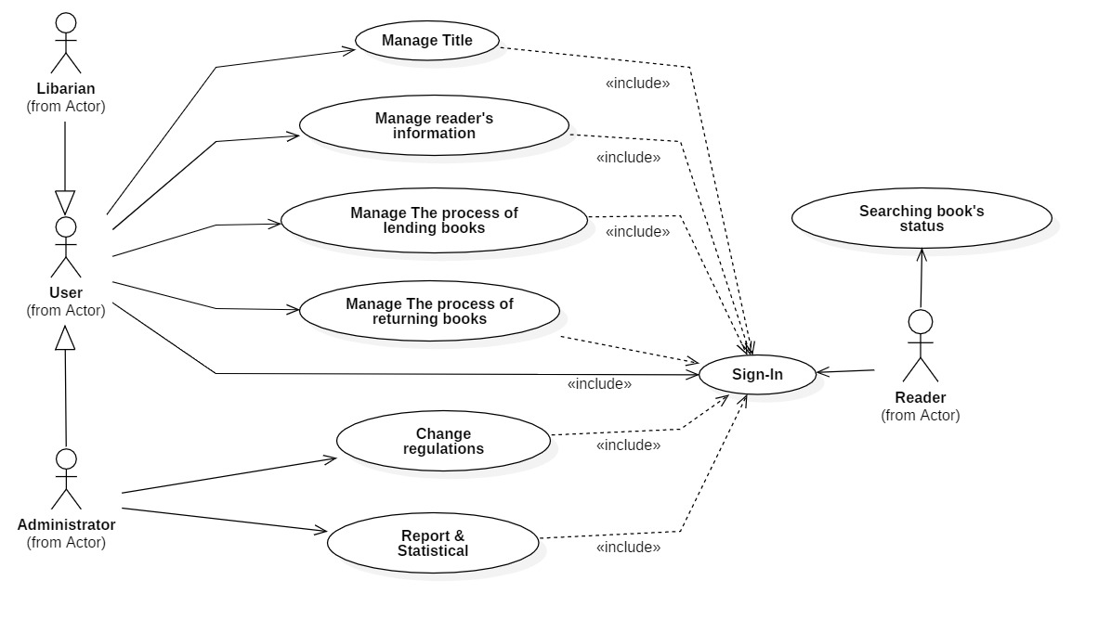

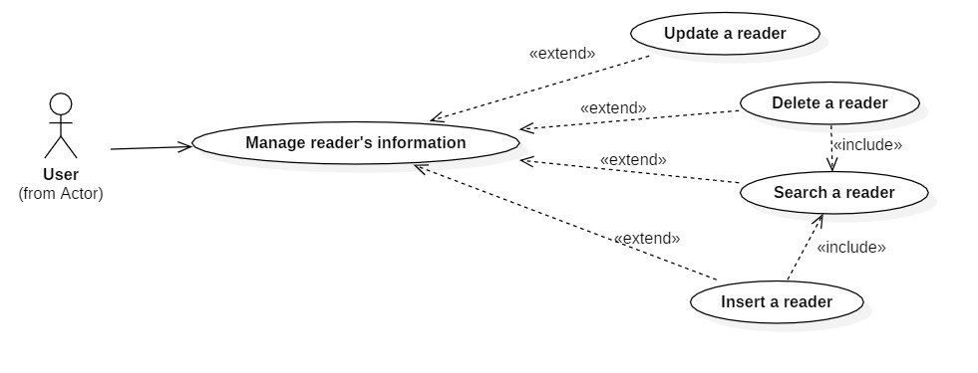

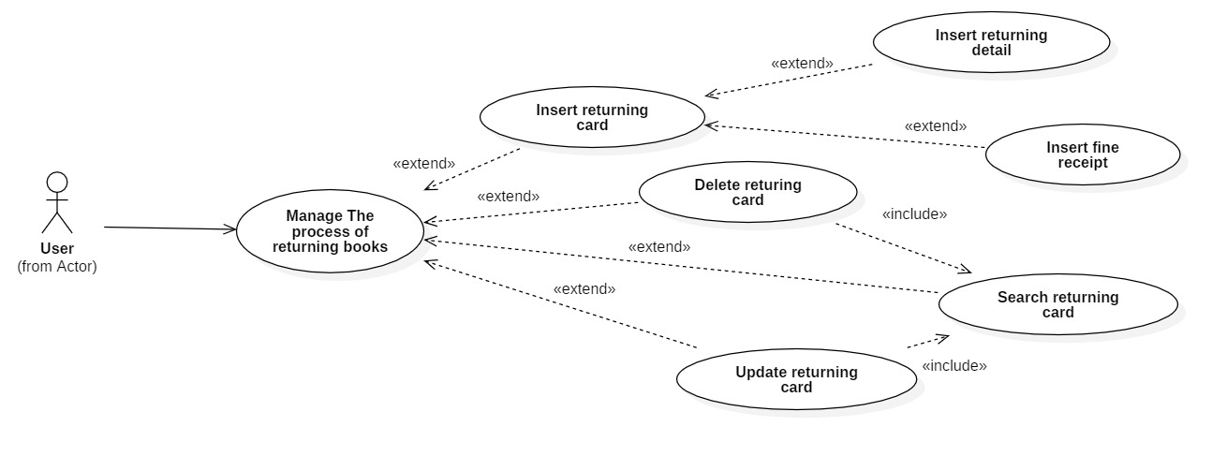

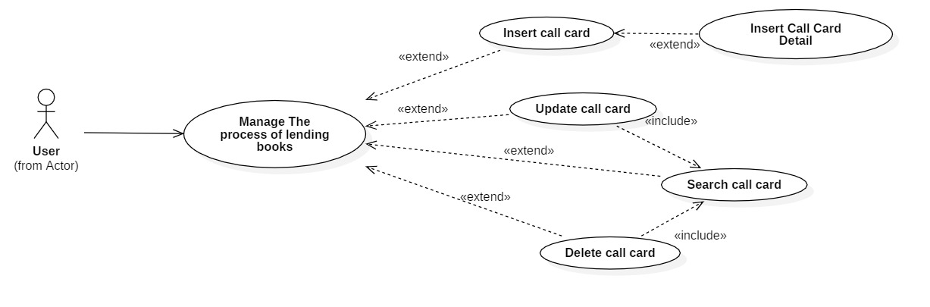

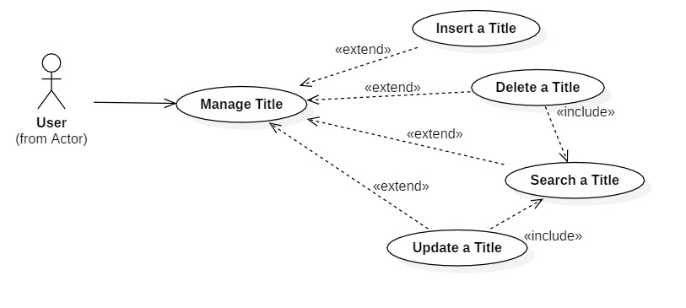

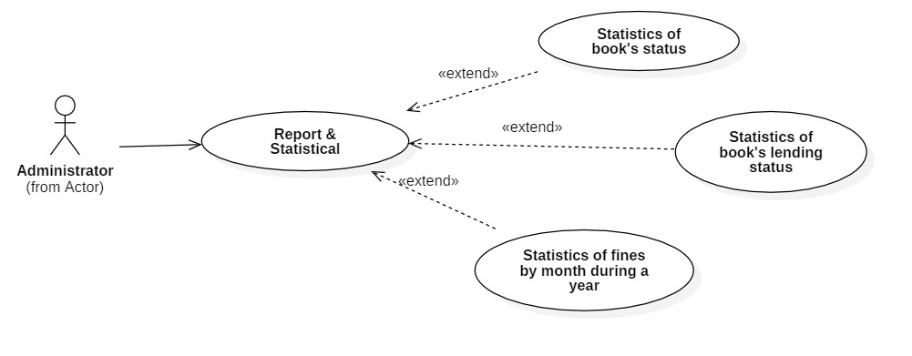

## **3.3 List of system actors**

|  |  |  |
| --- | --- | --- |
| Number | Actor | Description |
| 1 | Librarian |  |
| 2 | Reader |  |
| 3 | Manager | System manager, who can delegate permissions to employees and can also use all employee functions. |

## **3.4 List of usecase**

|  |  |  |
| --- | --- | --- |
| Number | Usecase | Description |
| 1 | Log in | Actor login to the system |
| 2 | Manage titles | Insert, delete, update and search tittle information |
| 3 | Manage reader | Insert, delete, update and search reader information |
| 4 | Look up book status | Look up if the book is available or is being lent to serve borrowing needs |
| 5 | Manage the process of borrowing books | Insert, delete, update and search call card information |
| 6 | Manage the return of books | Insert, delete, update and search return card information |
| 7 | Statistic | Book status statistics, book loan status statistics, book late return status |

Actor and use case

|  |  |
| --- | --- |
| Actor | Use case |
| Librarian | Log in |
| Manage titles |
| Manage reader information |
| Look up book status |
| Manage the process of borrowing books |
| Manage the return process |
| Manager | Log in |
| Manage titles |
| Manage reader information |
| Look up book status |
| Manage the process of borrowing books |
| Manage the return process |
| Statistic |
| Reader | Look up book status |

## **3.5 Usecase specification and activity diagram**

### **3.5.1 Sign in usecase**

|  |  |
| --- | --- |
| Usecase name | Sign up |
| Description | This use case describes the user's login steps to the system. |
| Actor | Manager, librarian |
| Trigger |  |
| Precondition | User is granted an account to access the system. |
| Postcondition | If successful, the user can operate on the system. Otherwise, display login failed message. |
| Basic flow | 0. User click on sign in button  1. System display signin page  2. User enter username & password and click confirm.  3. System validate username & password in correct format.  4. System validate user’s input data with existed account data in database.  5. System store signin status using sessions.  6. System displays successful signedin and redirect to home page.  7. System save user signin status. |
| Alternative flow |  |
| Exception flow |  |

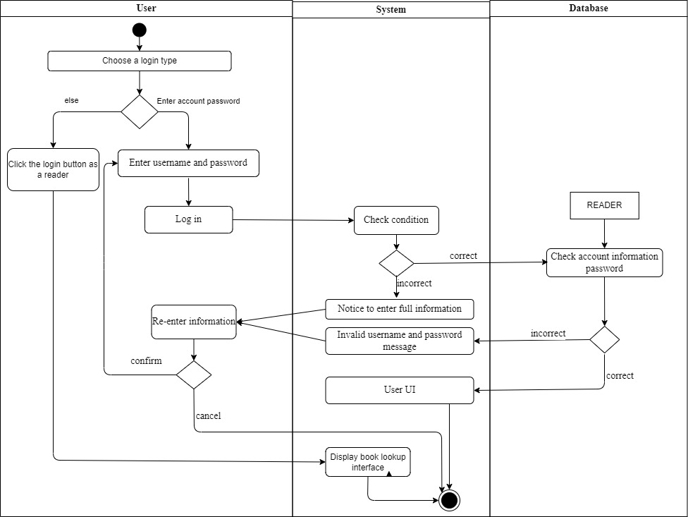

### **3.5.2 Book tittle management usecase**

* + - 1. **Display titles**

|  |  |
| --- | --- |
| **Usecase name** | **Manage titles** |
| **Description** | Users can add, delete, update, and look up showtimes on the system |
| **Actor** | Manager, librarian |
| **Trigger** |  |
| **Precondition** | User signed in system |
| **Postcondition** | If successful, display a success message, the information is updated in the database. Otherwise, the operation failed message |
| **Basic flow** | Display book title  Insert book title  Update book title  Delete book title  Search book title |
| **Alternative flow** |  |
| **Exception flow** |  |

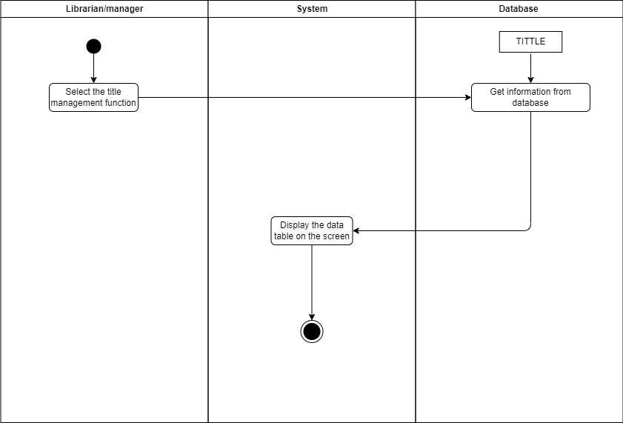

* + - 1. **Insert Title**

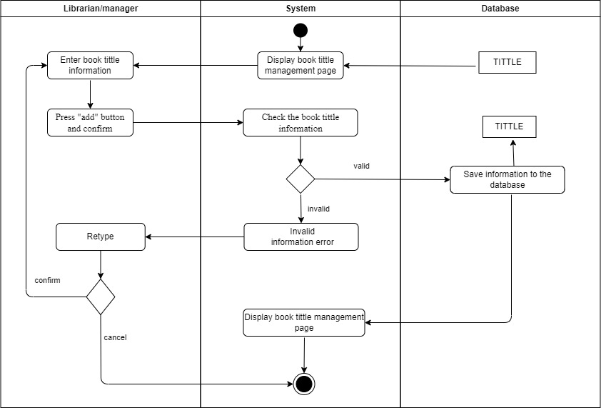

* + - 1. **Update Title**

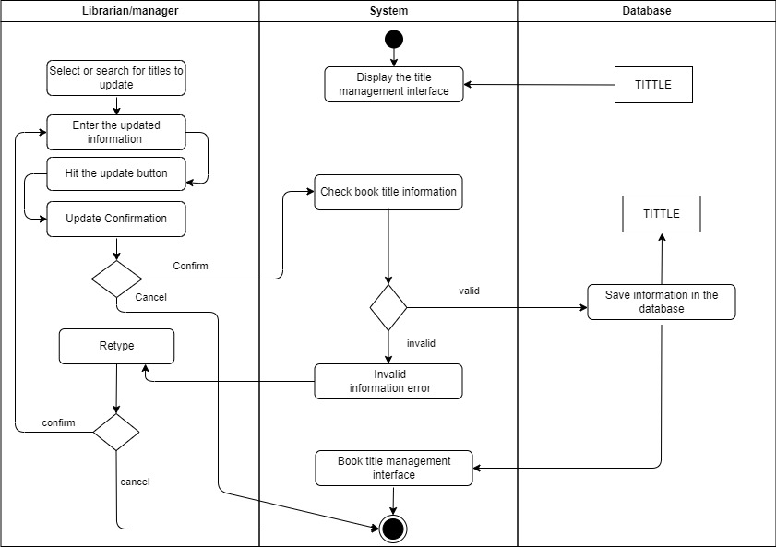

* + - 1. **Delete Title**

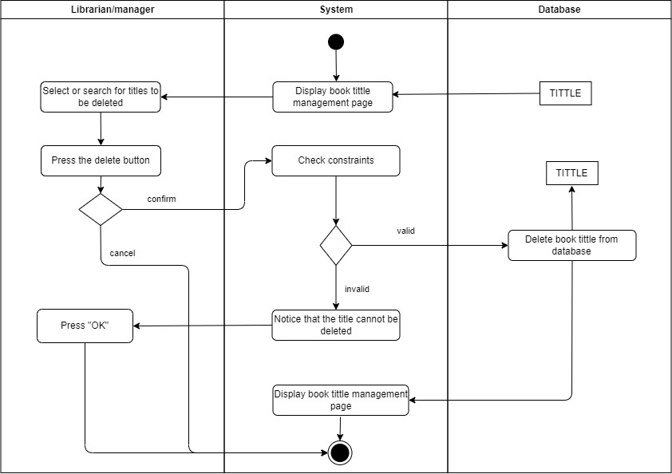

* + - 1. **Search Title**

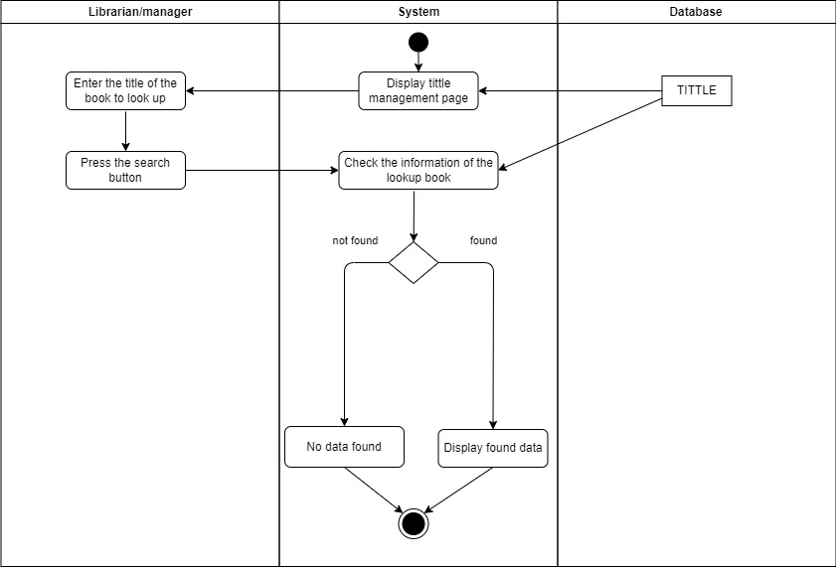

* + - 1. **Add Book**

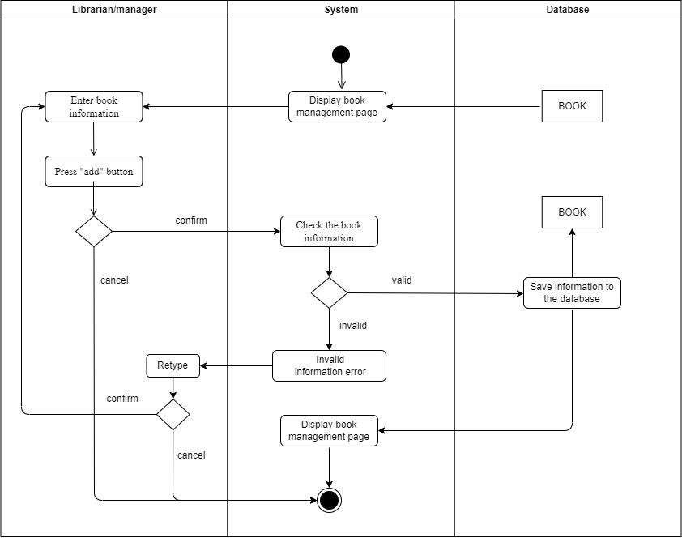

### **3.5.3 Manage Reader**

|  |  |
| --- | --- |
| Usecase name | Manage Reader |
| Description | Administrator can insert, delete, update and search reader information |
| Actor | Manager, librarian |
| Trigger |  |
| Precondition | Signed in manage’s account or librarian's account |
| Postcondition | If the new addition is successful then add the book title to the system.  If the deletion is successful then delete the title from the system.  If the update is successful then update the title information in the system. |
| Basic flow | Display Reader  Insert Reader  Delete Reader  Update Reader  Search Reader |
| Alternative flow |  |
| Exception flow |  |

#### **3.5.3.1 Display Reader**

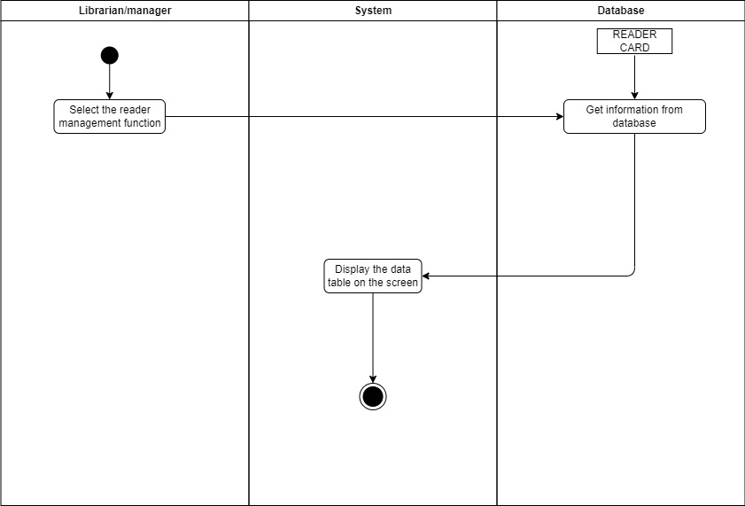

#### **3.5.3.2 Insert Reader**

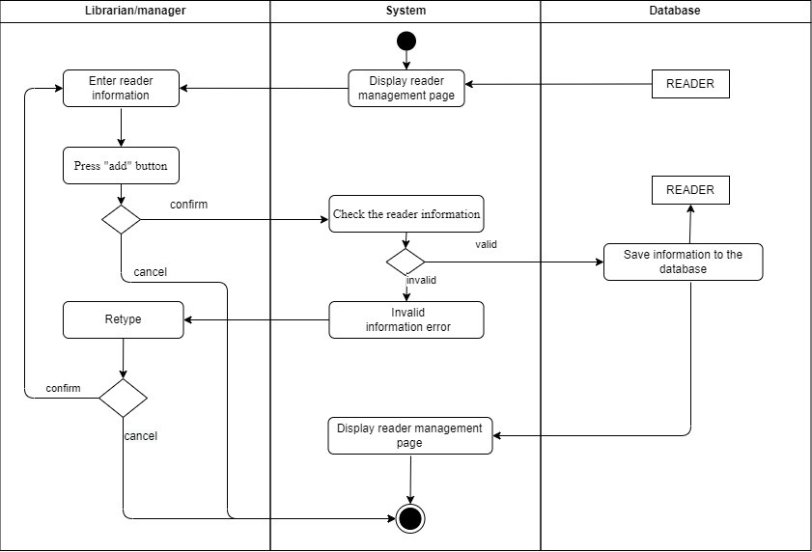

#### **3.5.3.3 Update Reader**

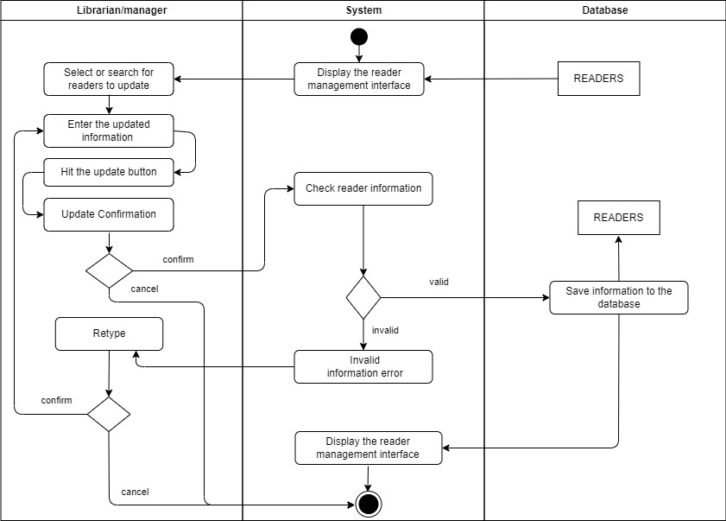

#### **3.5.3.4 Delete Reader**

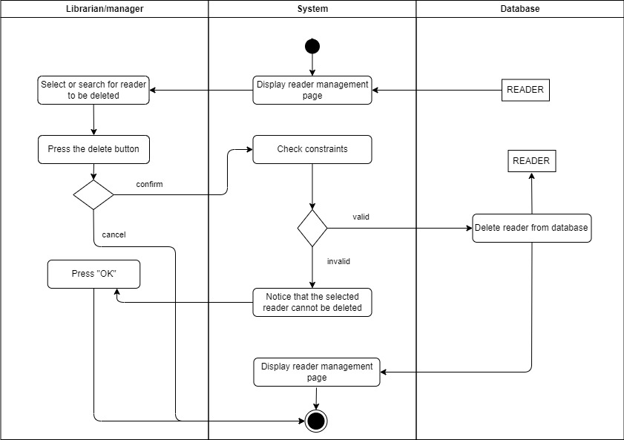

#### **3.5.3.5 Search Reader**

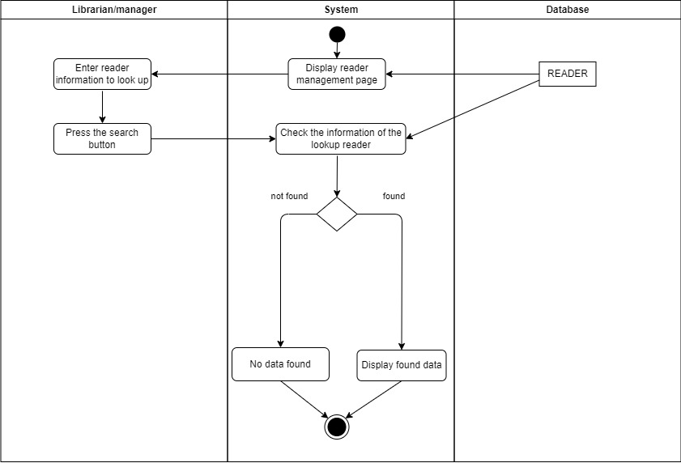

### **3.5.4 Look Up Book Status**

|  |  |
| --- | --- |
| Usecase name | Look Up Book Status |
| Description | Use case allows users to look up the status of book titles to borrow books |
| Actor | Librarian, Manage, Reader |
| Trigger |  |
| Precondition |  |
| Postcondition | The user looks up the status of the book successfully. |
| Basic flow |  |
| Alternative flow |  |
| Exception flow |  |

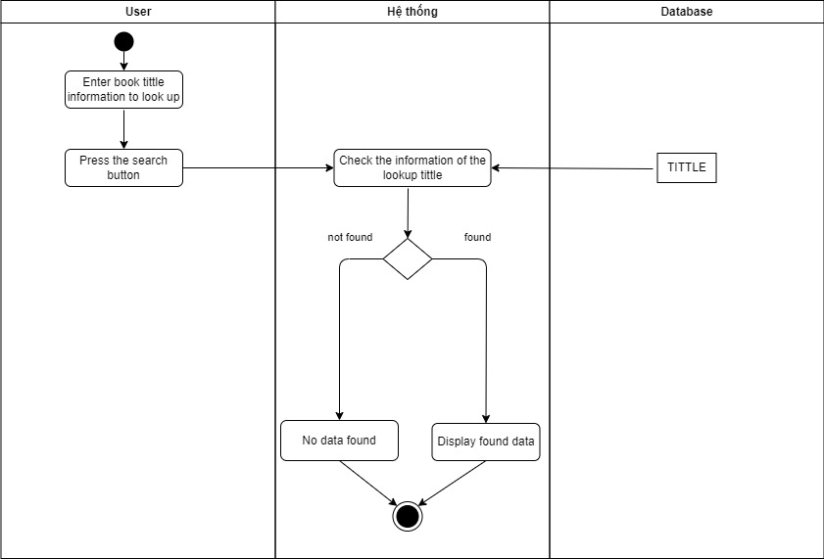

### **3.5.5 Manage The Process Of Borrowing Books**

|  |  |
| --- | --- |
| Usecase name | Manage the Process of Borrowing Book |
| Description | Use case allows users to add, delete, update, and search call card. |
| Actor | Librarian, Manage |
| Trigger |  |
| Precondition | User signed in system |
| Postcondition | If the new add is successful then add the call card to the system.  If the delete is successful then the call card will be deleted from the system.  If the update is successful then update the information the call card in the system. |
| Basic flow | Display information call card  Insert call card  Update call card  Delete call card  Search call card  Insert borrow book details |
| Alternative flow |  |
| Exception flow |  |

#### **3.5.5.1 Display Call Card**

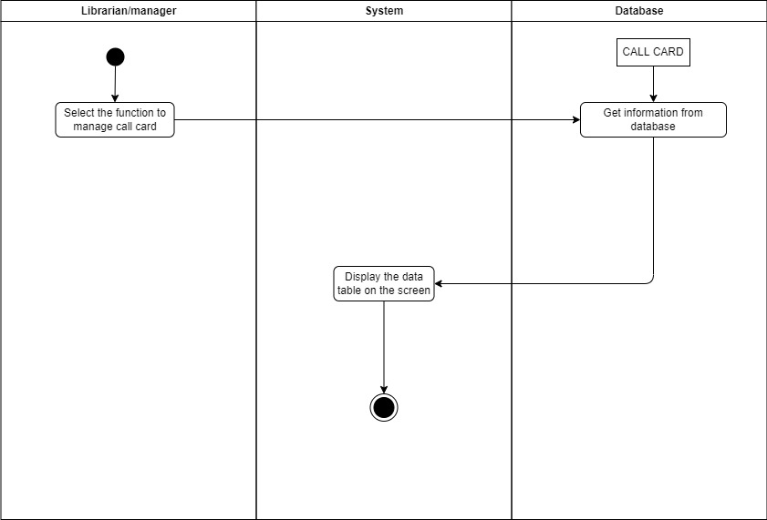

#### **3.5.5.2 Insert Call Card**

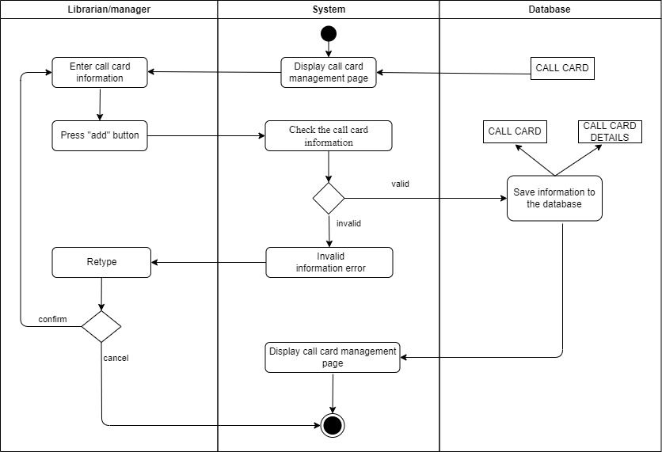

#### **3.5.5.3 Update Call Card**

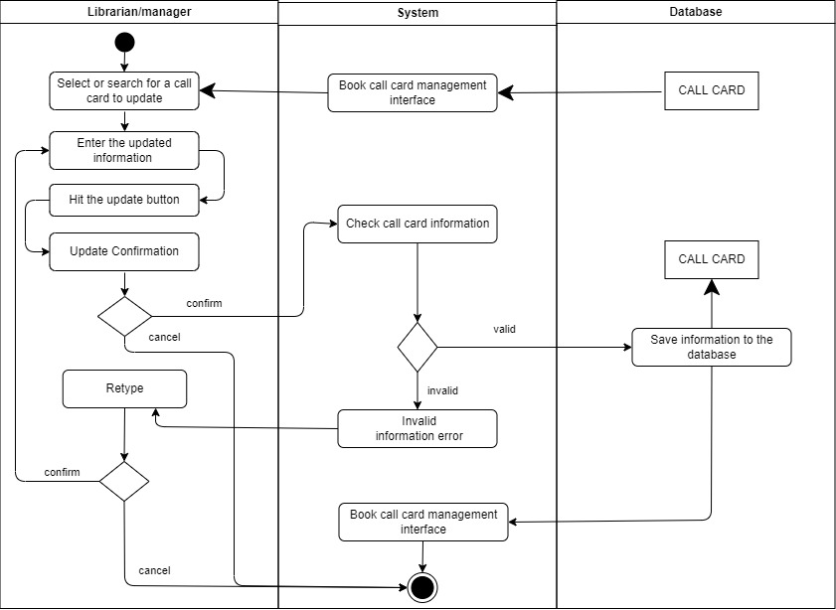

#### **3.5.5.4 Delete Call Card**

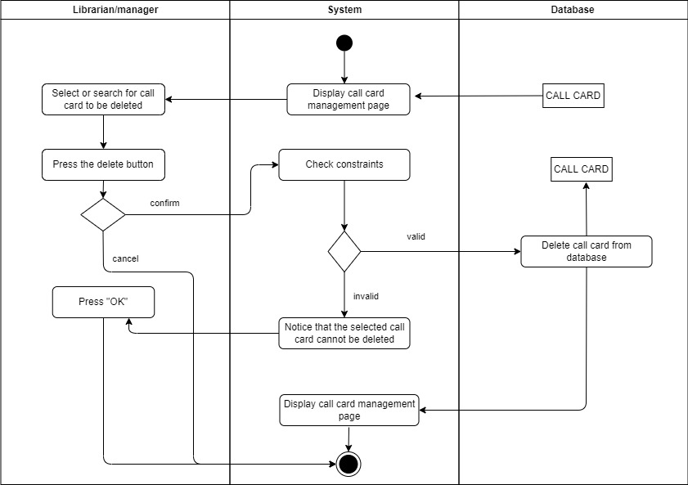

#### **3.5.5.5 Search Call Card**

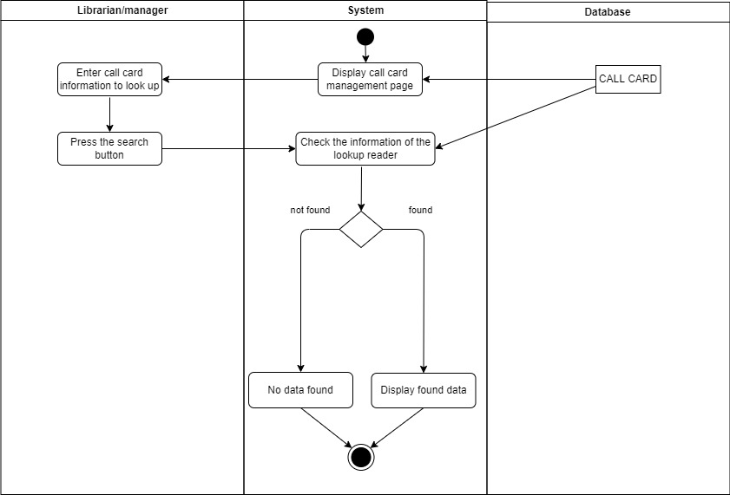

#### **3.5.5.6 Insert Borrow Books Details**

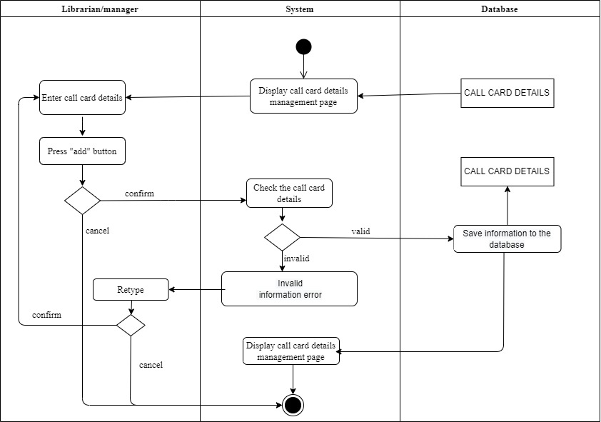

### **3.5.6 Manage The Return Process**

|  |  |
| --- | --- |
| Usecase name | Manage the Return Process |
| Description | Use case allows users to add, delete, update, search for return card, and at the same time make a receipt to collect fines when a reader returns a book late or loses a book. |
| Actor | Librarian, Manage |
| Trigger |  |
| Precondition | User signed in system |
| Postcondition | If the new add is successful then add the return card to the system.  If the delete is successful then the return card will be deleted from the system.  If the update is successful then update the return card information in the system.  If add the fine collection ticket is successful then add the receipt to the system. |
| Basic flow | Display return card  Insert return card  Update return card  Delete return card  Search return card  Insert book return detail |
| Alternative flow |  |
| Exception flow |  |

#### **3.5.6.1 Display Return Card**

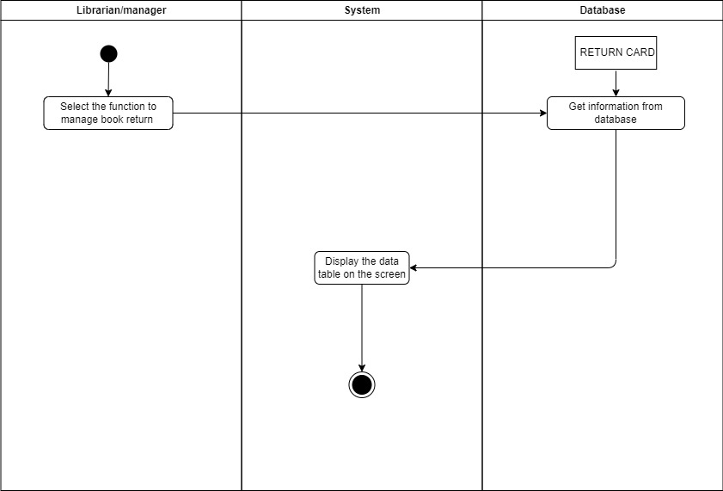

#### **3.5.6.2 Insert Return Card**

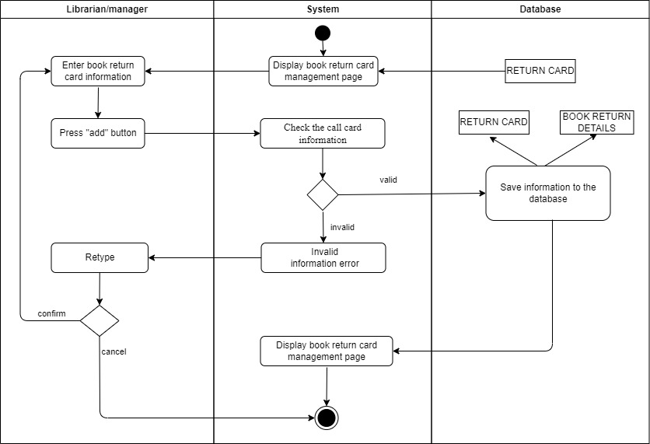

#### **3.5.6.3 Delete Return Card**

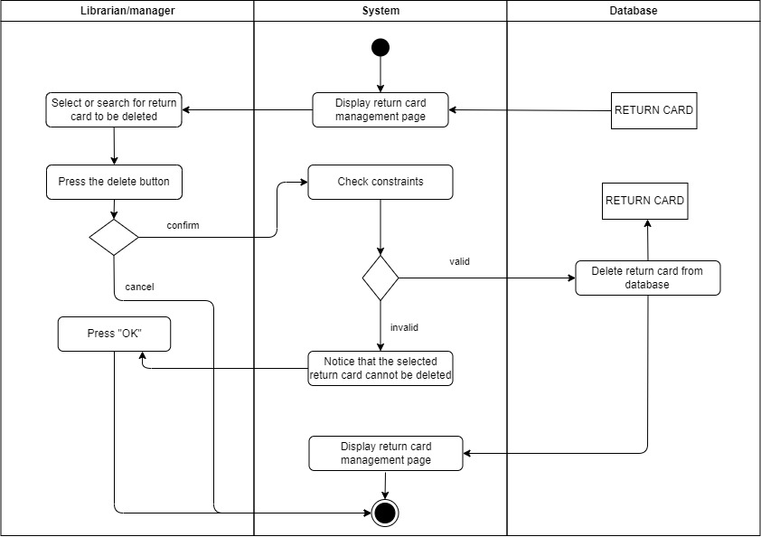

#### **3.5.6.4 Update Return Card**

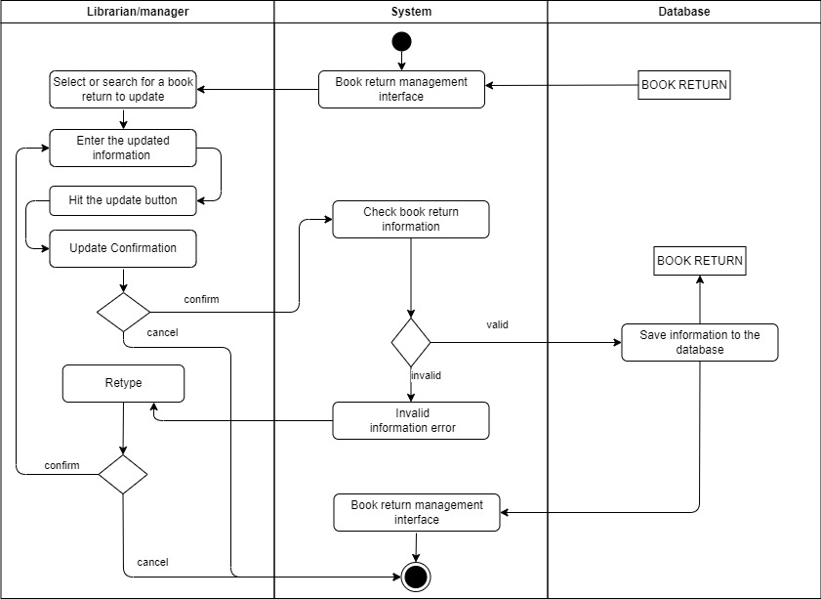

#### **3.5.6.5 Search Return Card**

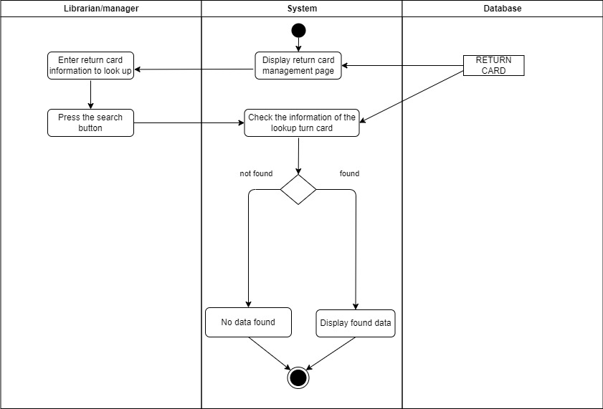

#### **3.5.6.6 Add Book Return Details**

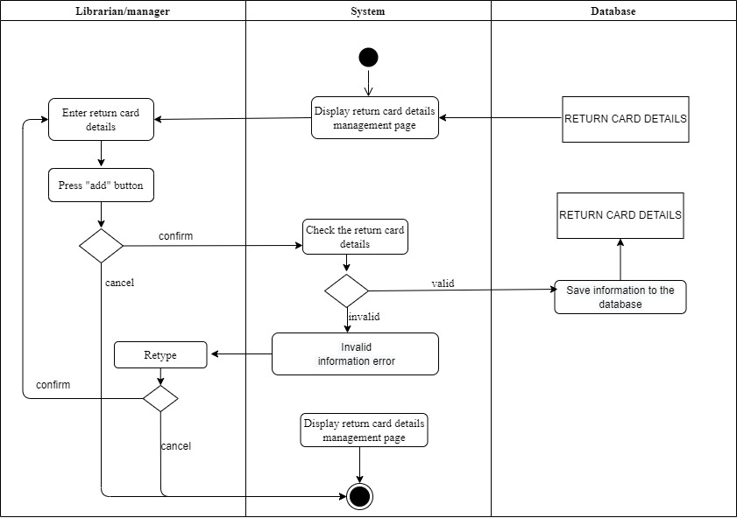

#### **3.5.6.7 Add Fines Receipts**

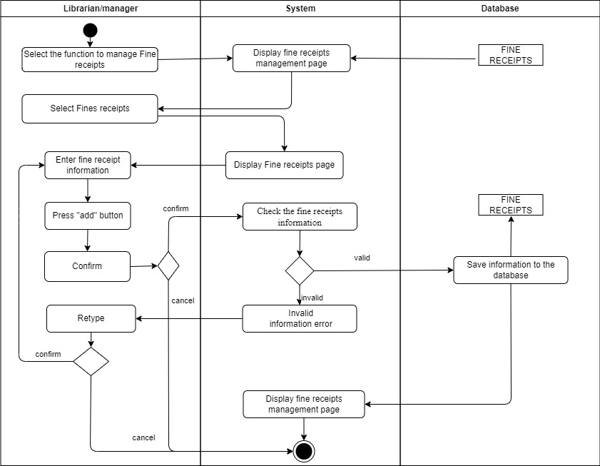

### **3.5.7 Statistic Report**

|  |  |
| --- | --- |
| Usecase name | Statistic Report |
| Description | Usecase allows users to report monthly fine statistics, book loan status in the month. |
| Actor | Librarian |
| Trigger |  |
| Precondition | Signed in librarian's account |
| Postcondition | The system will output report results when the analysis of the results takes place successfully. |
| Basic flow |  |
| Alternative flow |  |
| Exception flow |  |

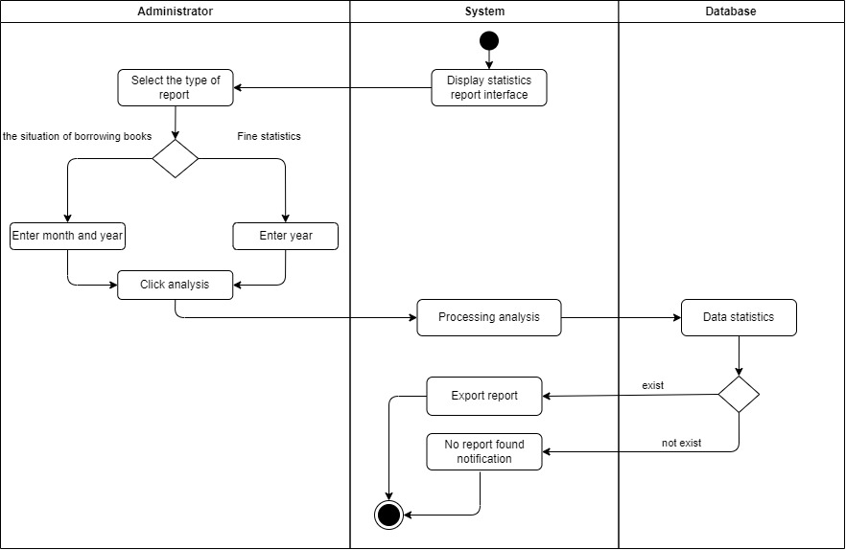

**3.6 Sequence Diagram**

### **3.6.1 Sequence Login**

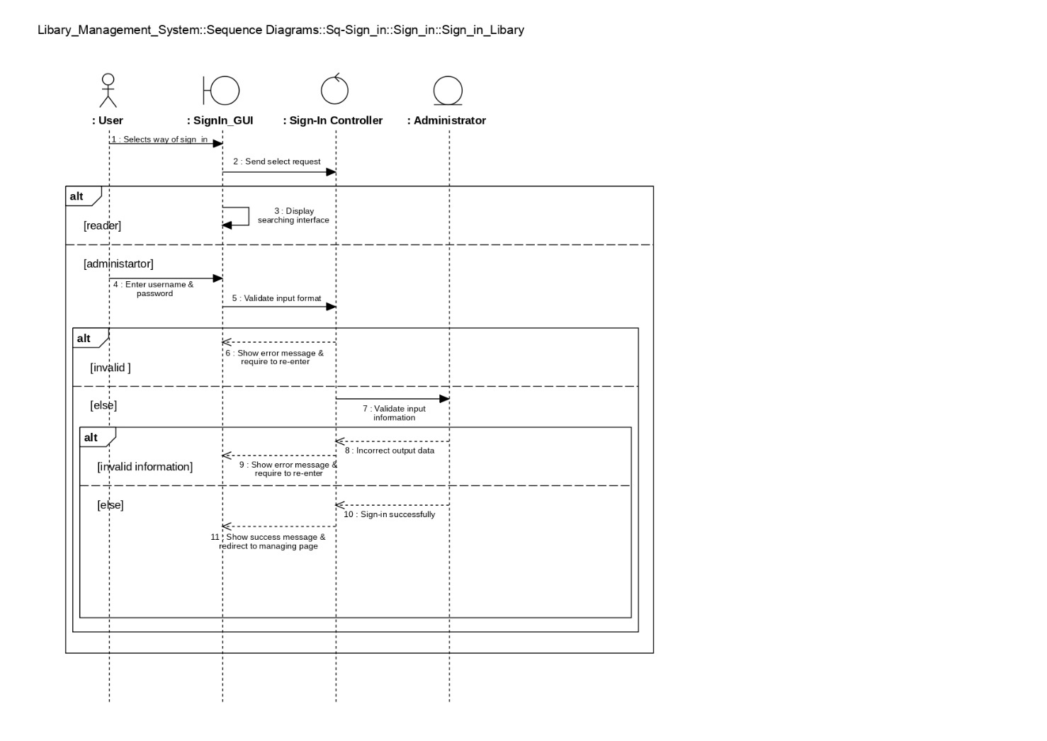

### **3.6.2 Sequence Manage Reader**

#### **3.6.2.1 Display Reader**

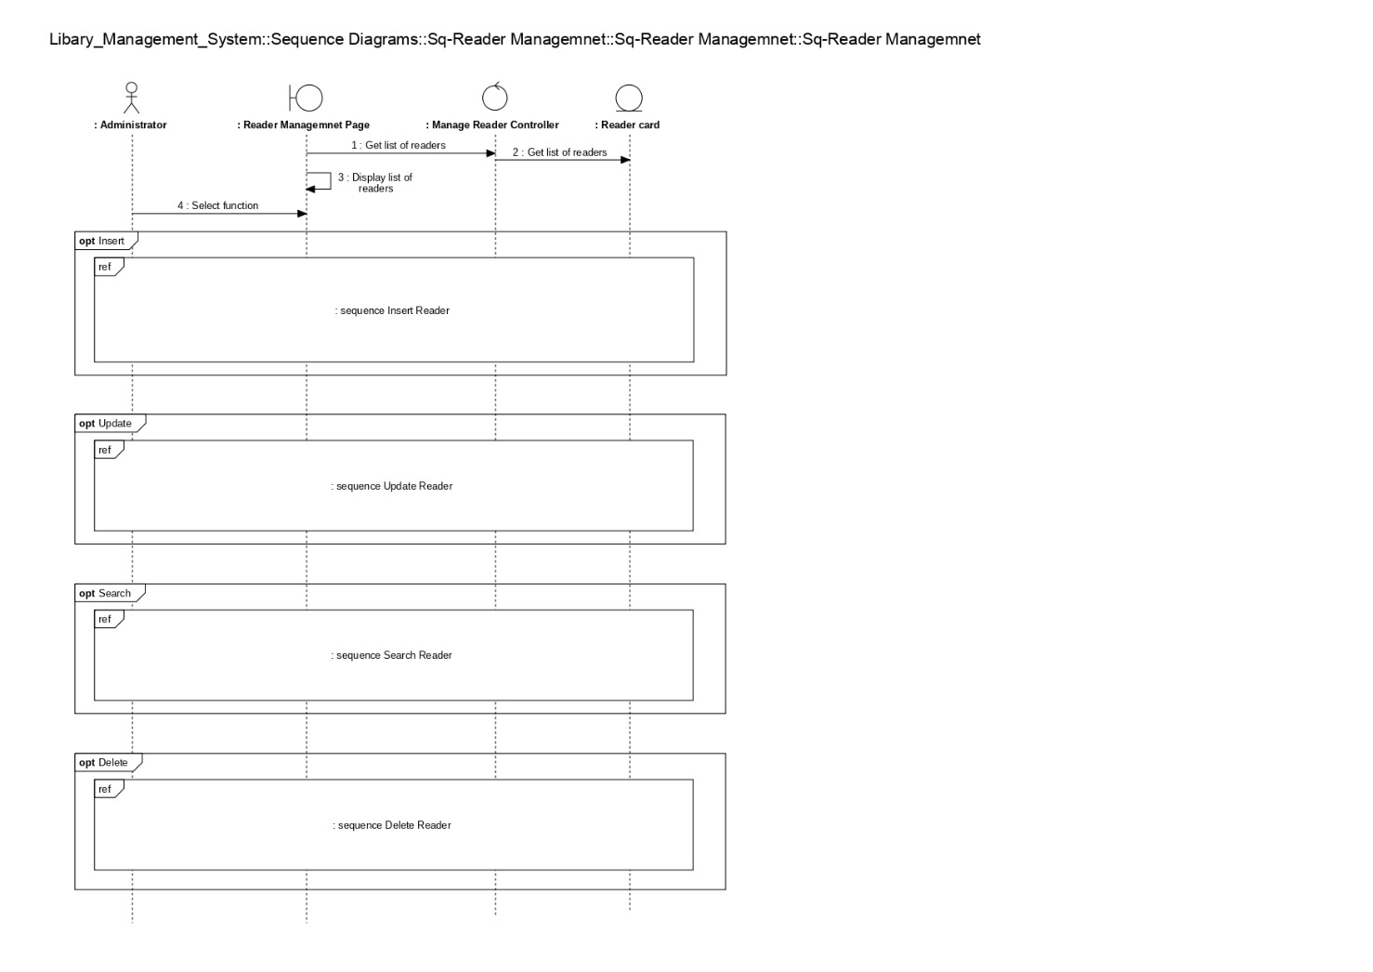

#### **3.6.2.2 Search Reader**

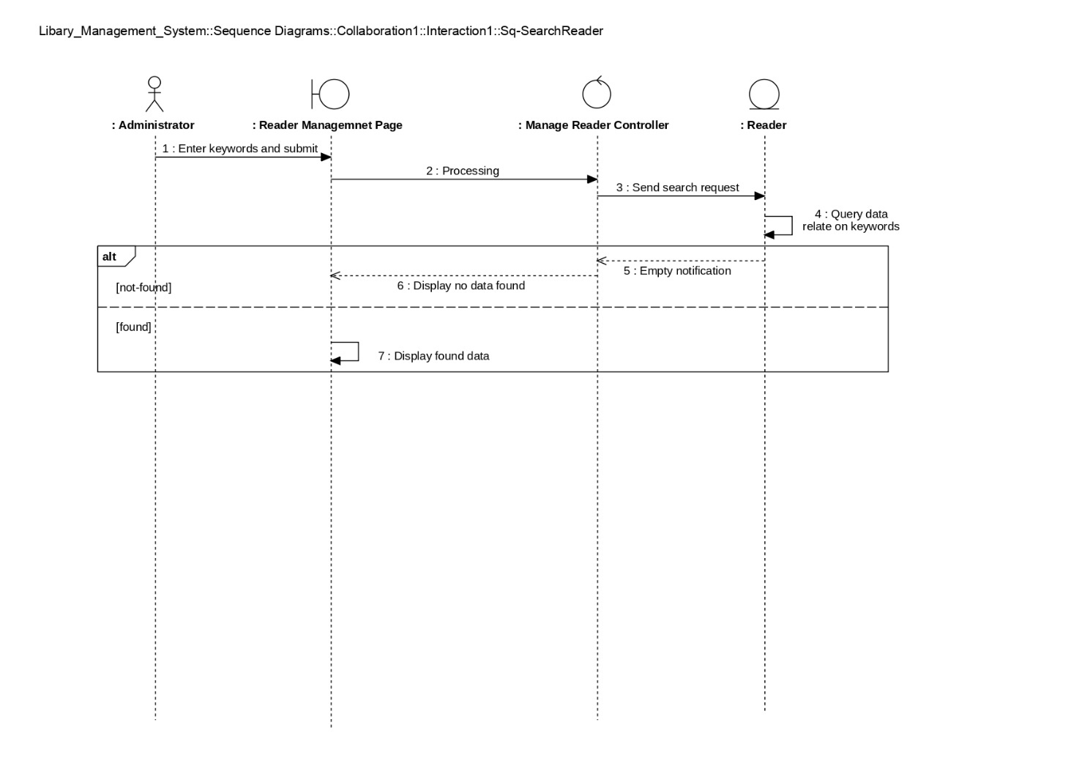

#### **3.6.2.3 Insert Reader**

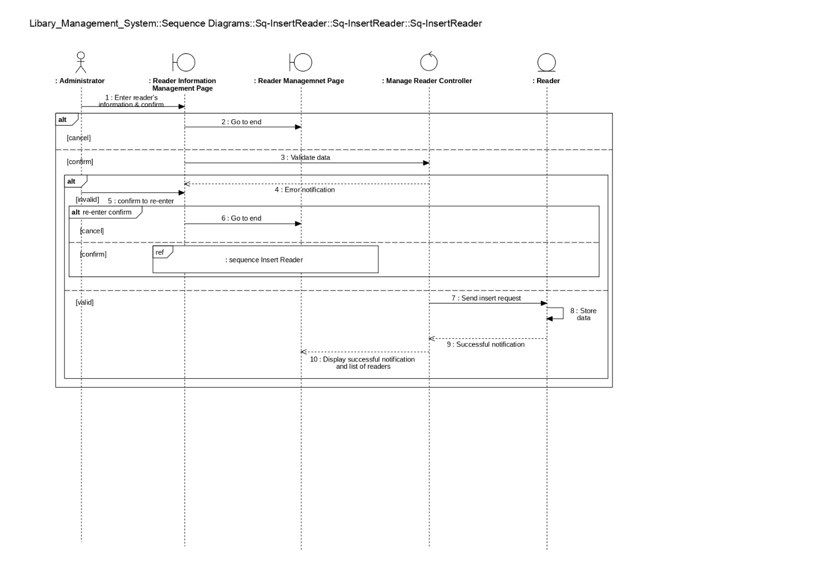

#### **3.6.2.4 Update Reader**

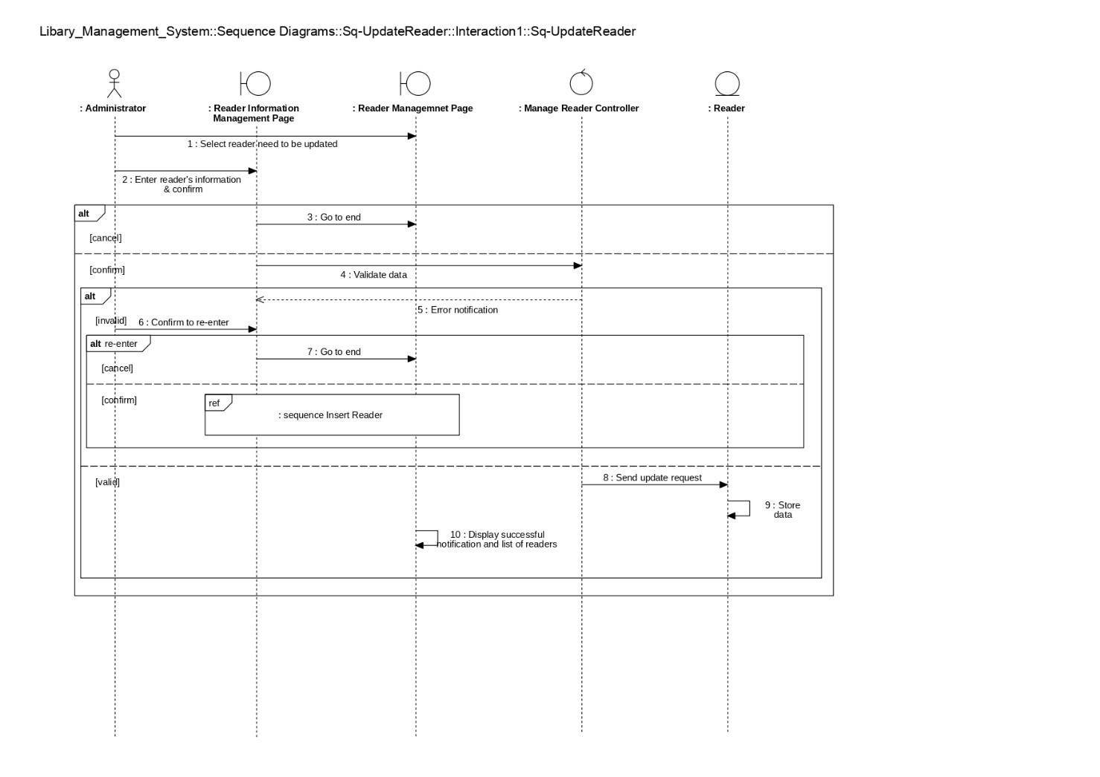

#### **3.6.2.5 Delete Reader**

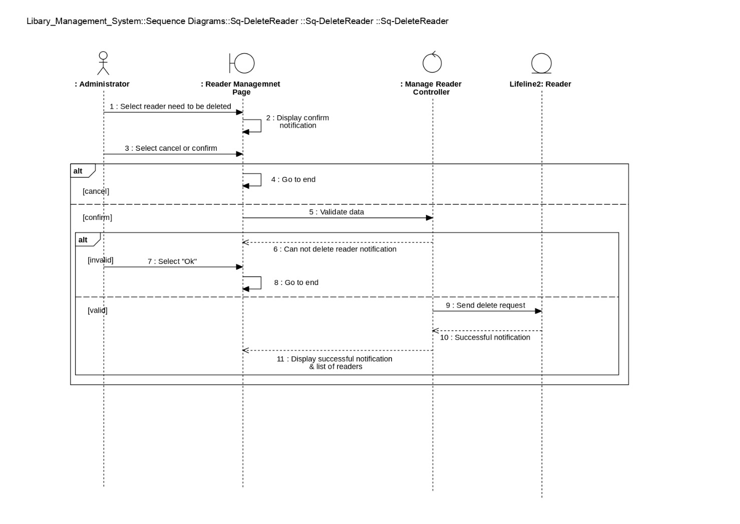

### **3.6.3 Sequence Manage Title**

#### **3.6.3.1 Display Title**

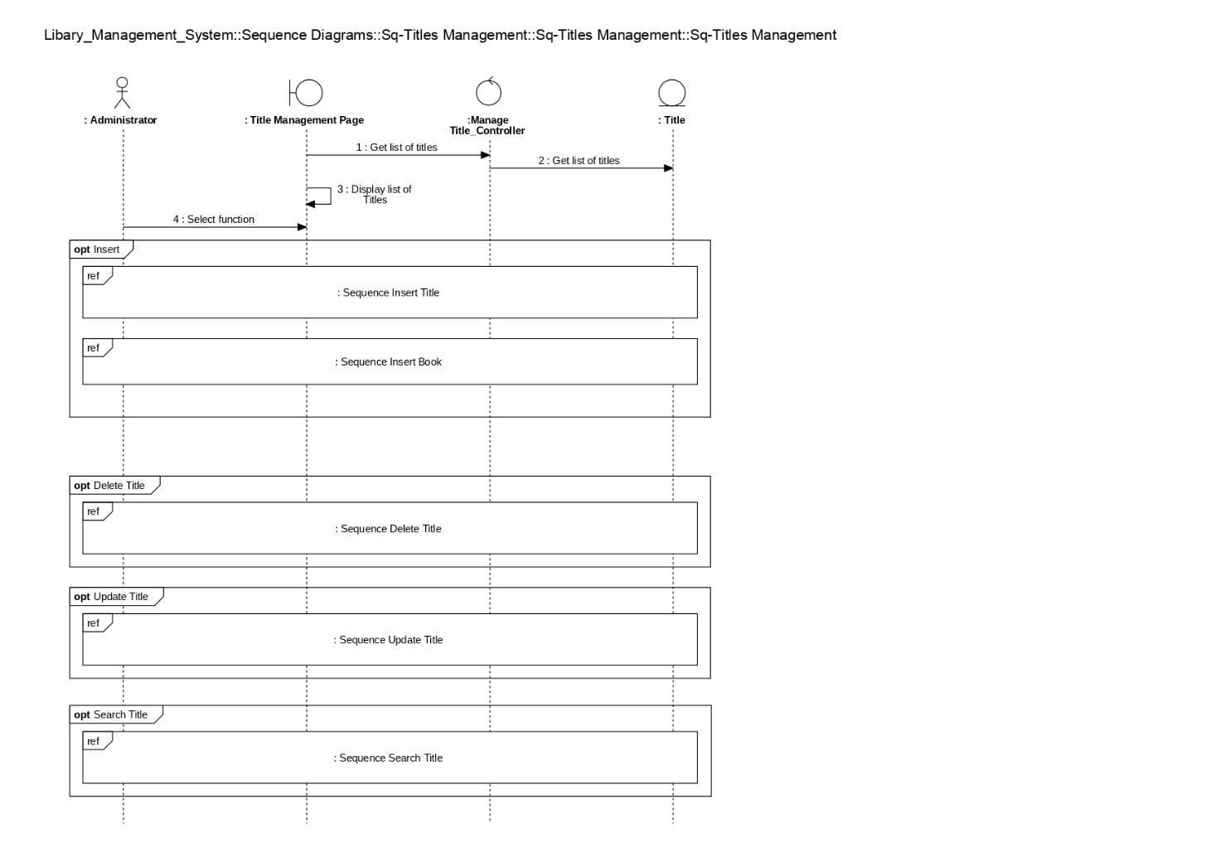

#### **3.6.3.2 Search Title**

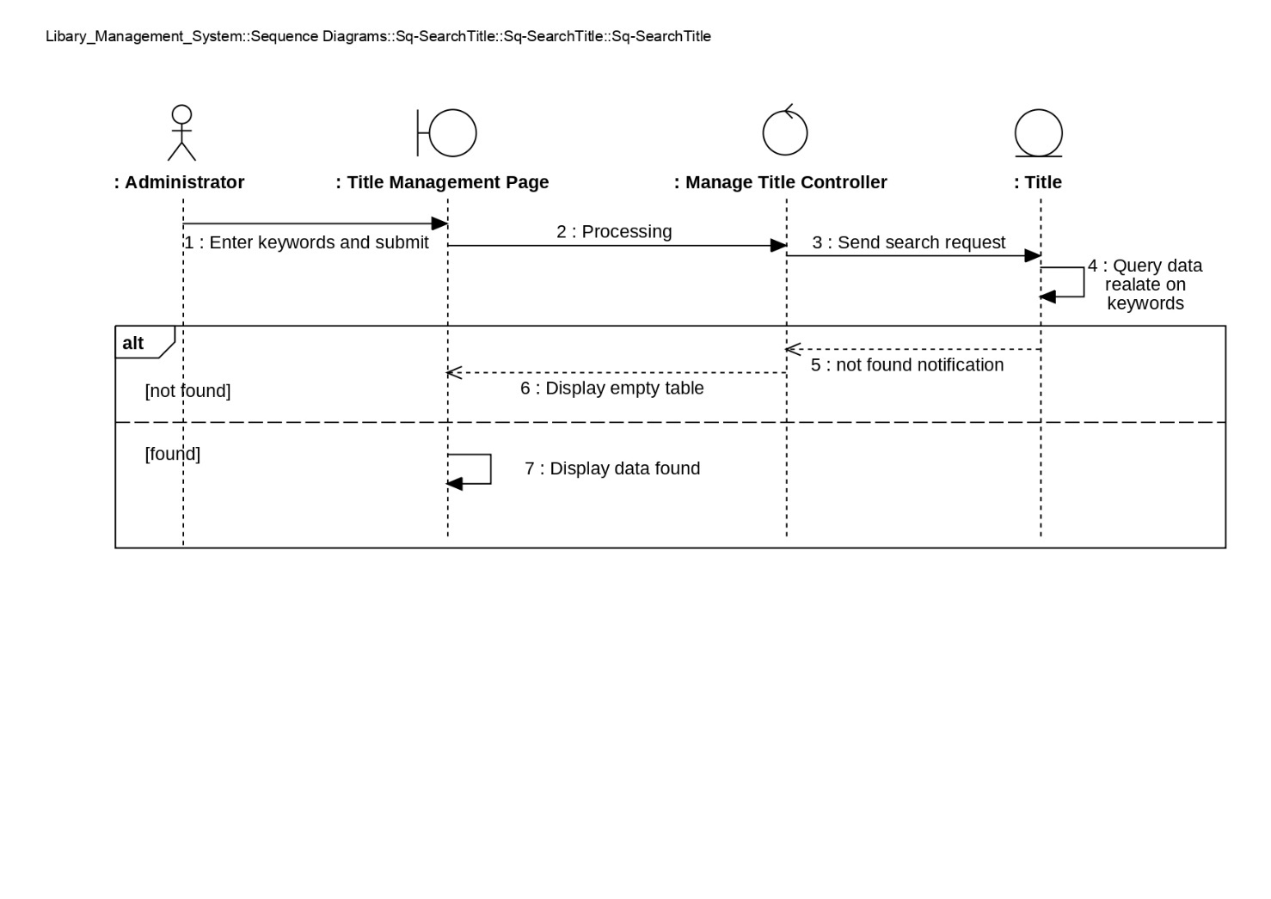

#### **3.6.3.3 Insert Title**

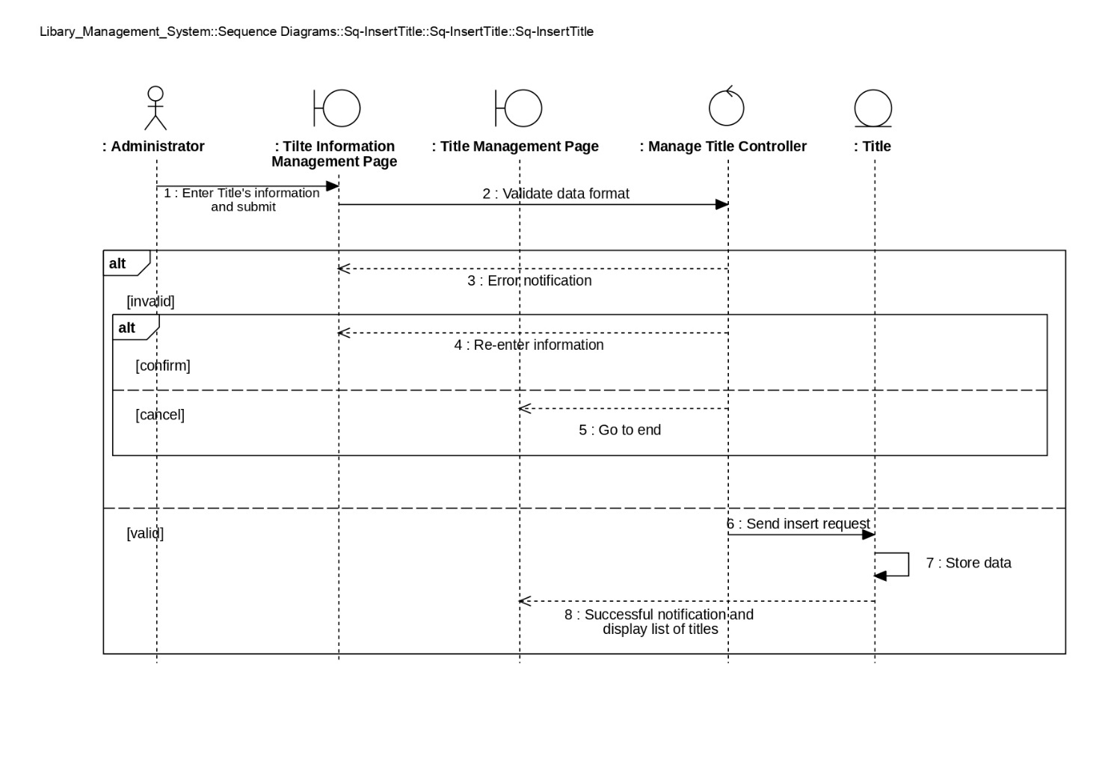

#### **3.6.3.4 Update Title**

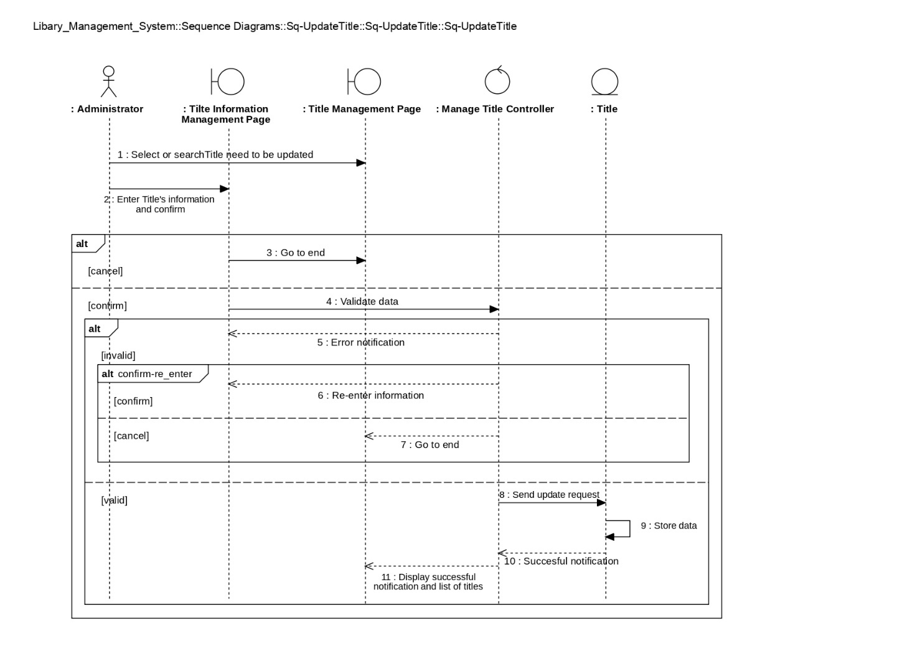

#### **3.6.3.5 Delete Title**

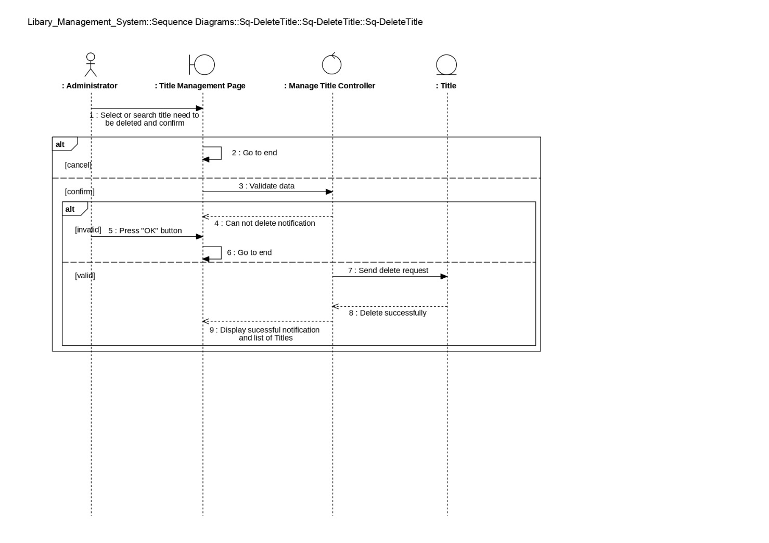

#### **3.6.3.6 Insert Book**

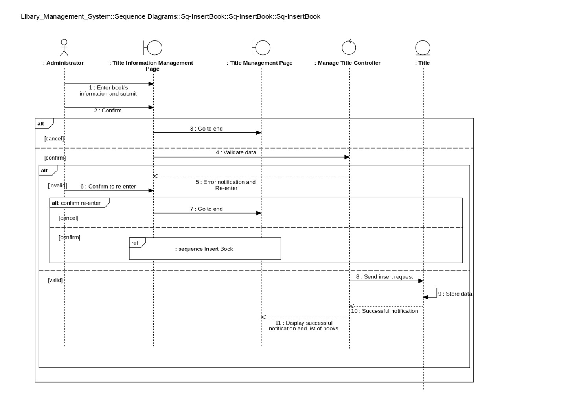

### **3.6.4 Sequence Look up book status**

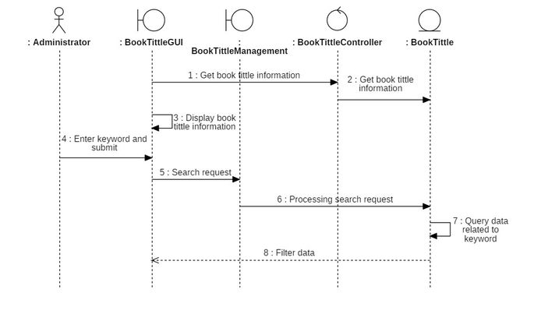

### **3.6.5 Squence Manage the process of borrowing books**

#### **3.6.5.1 Search call card**

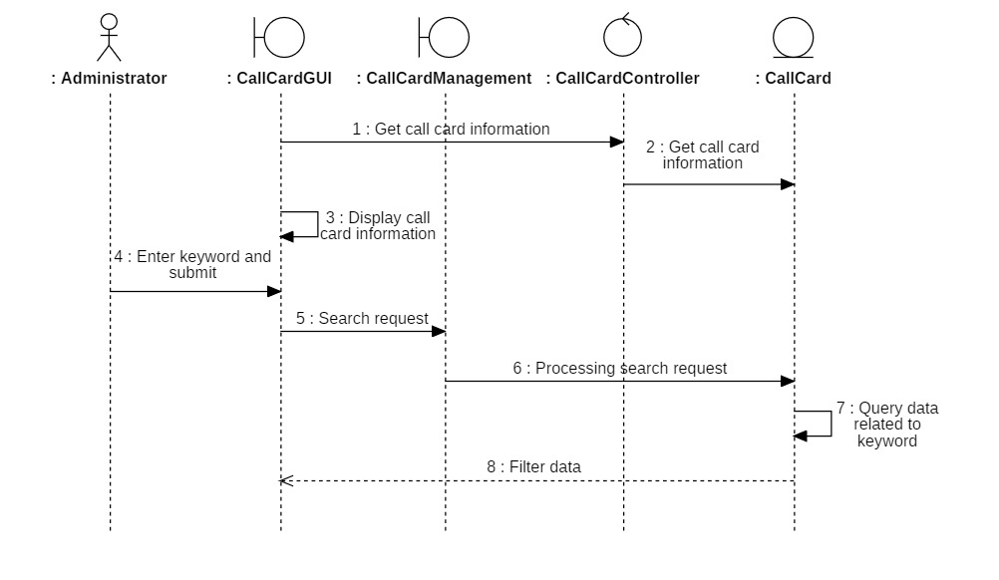

#### **3.6.5.2 Insert call card**

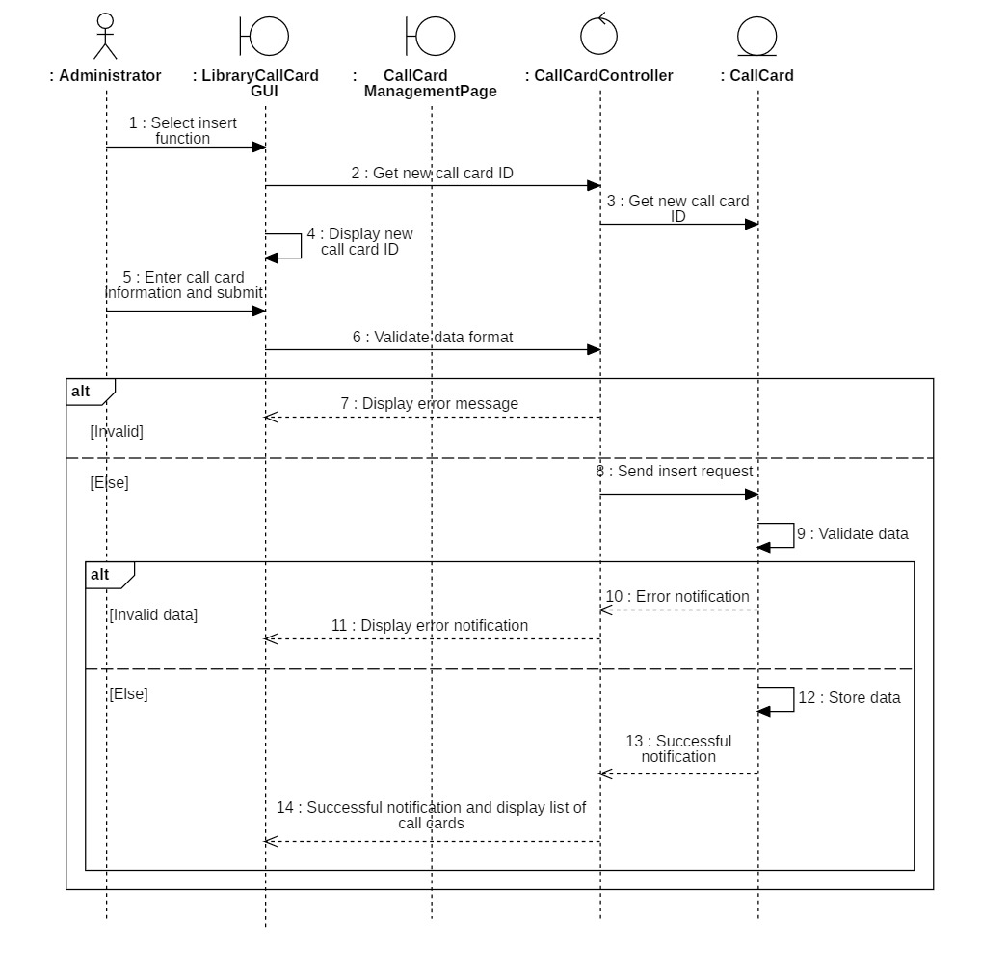

#### **3.6.5.3 Update call card**

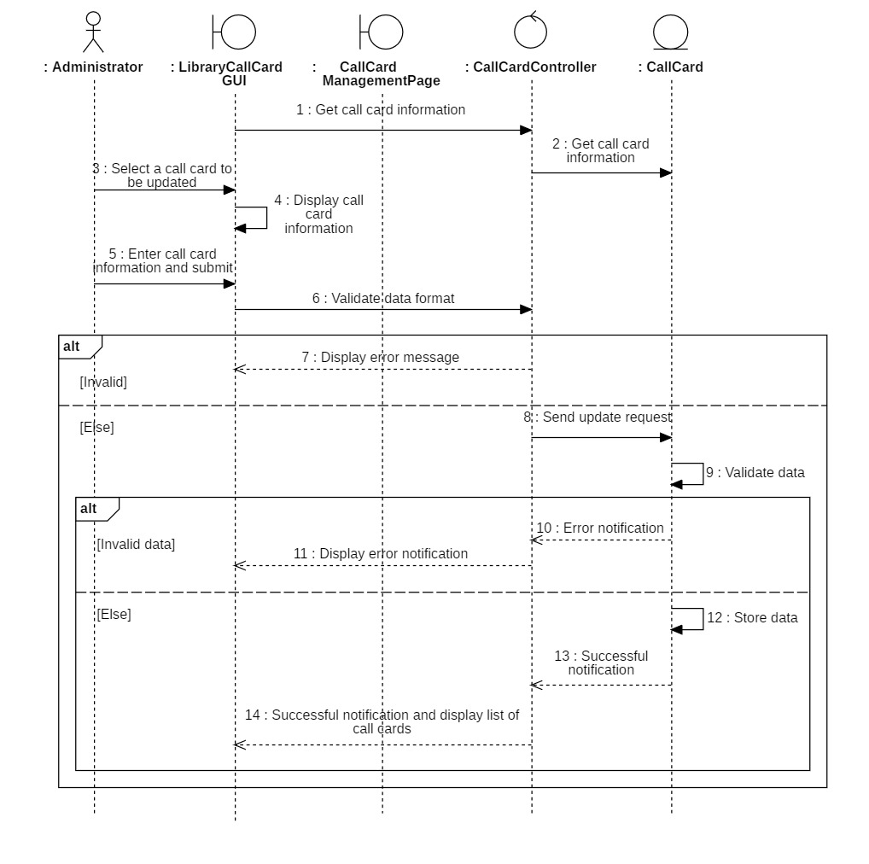

#### **3.6.5.4 Delete call card**

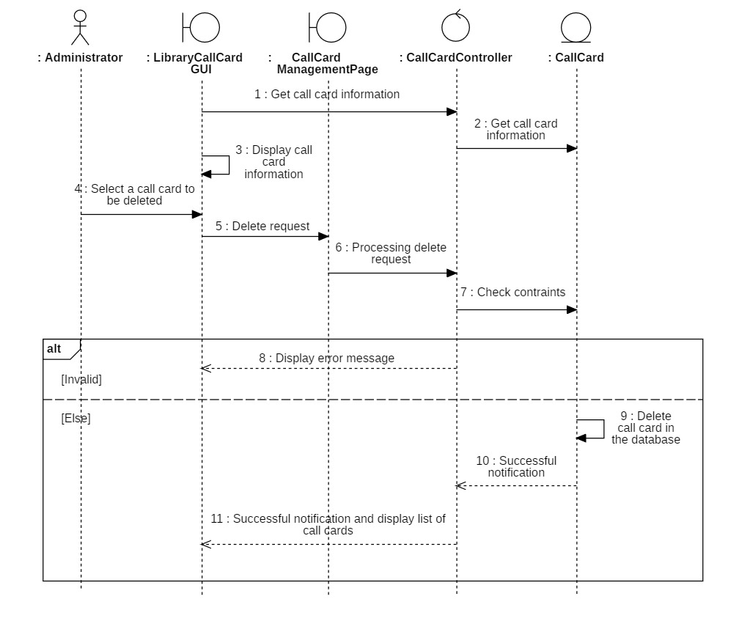

#### **3.6.5.6 Insert borrow book details**

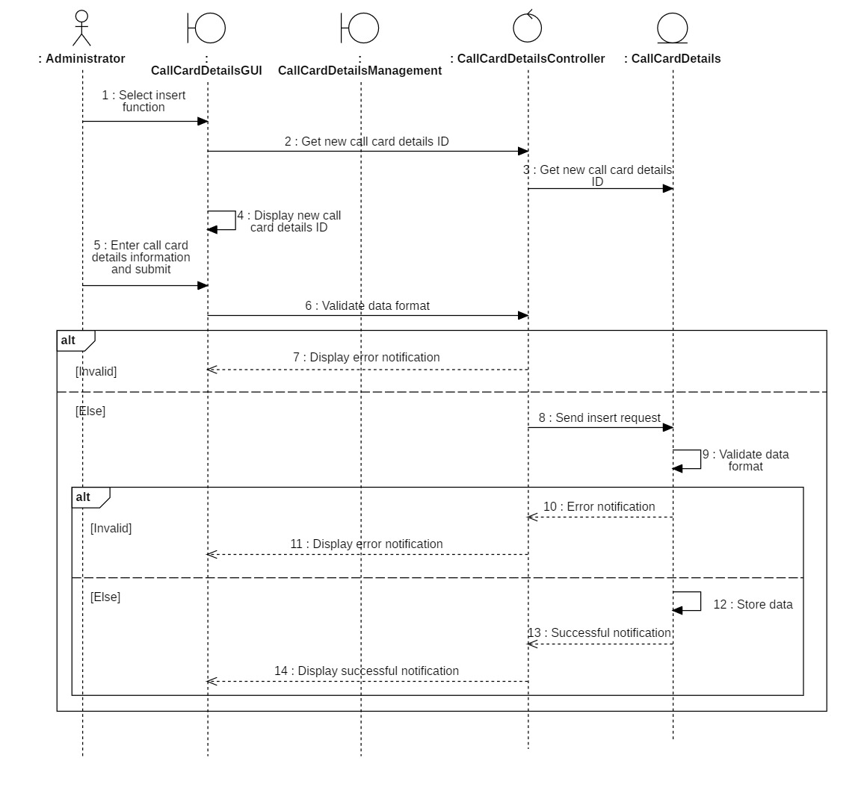

### **3.6.6 Manage the Return Process**

#### **3.6.6.1 Display return card**

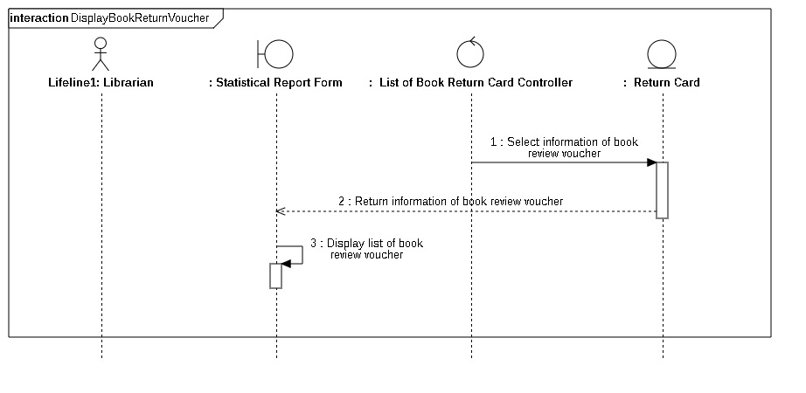

#### **3.6.6.2 Insert return card**

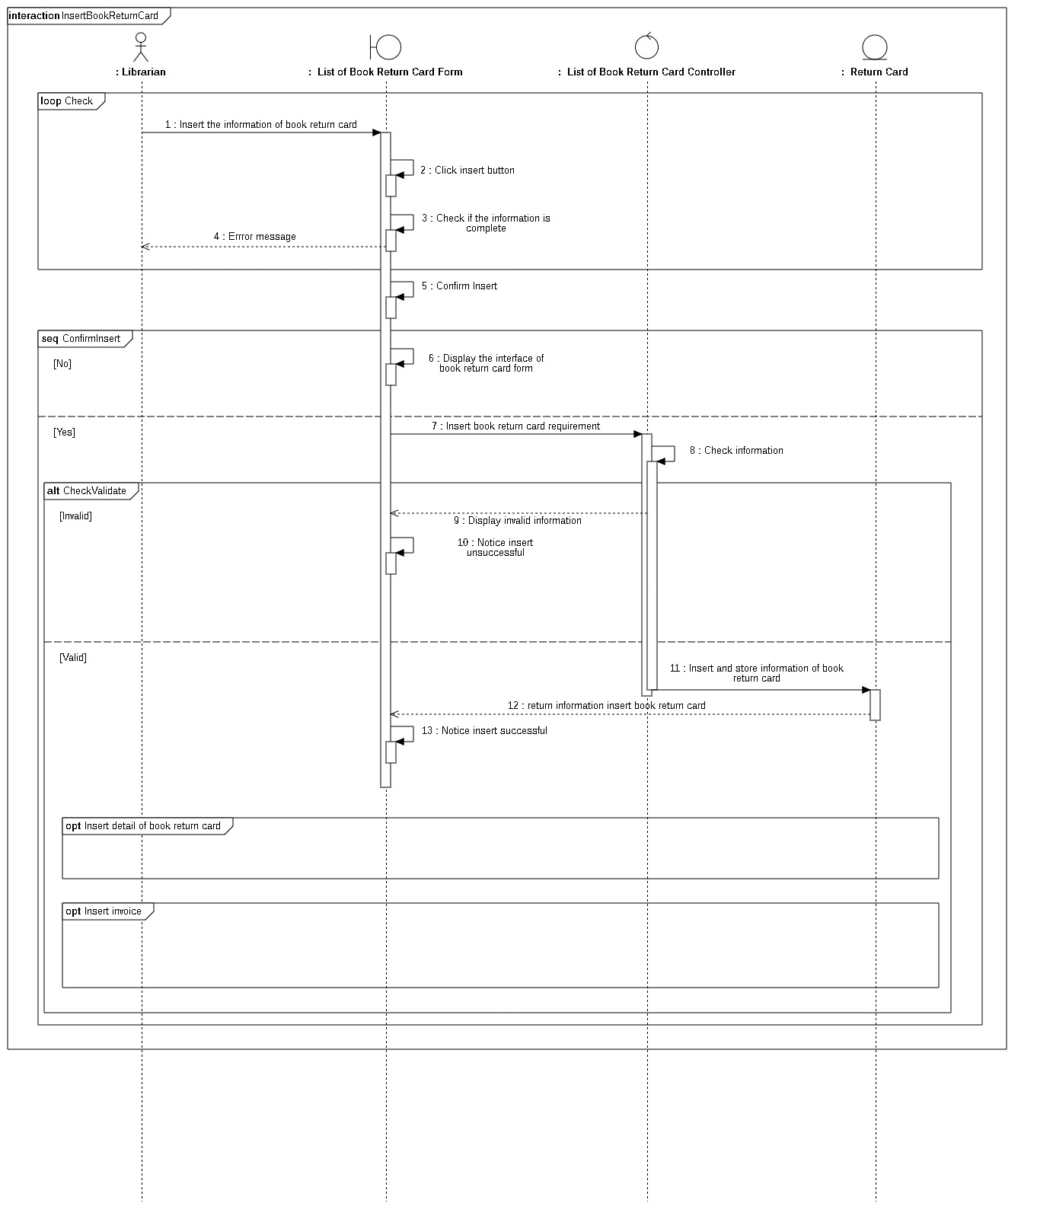

#### **3.6.6.3 Update return card**

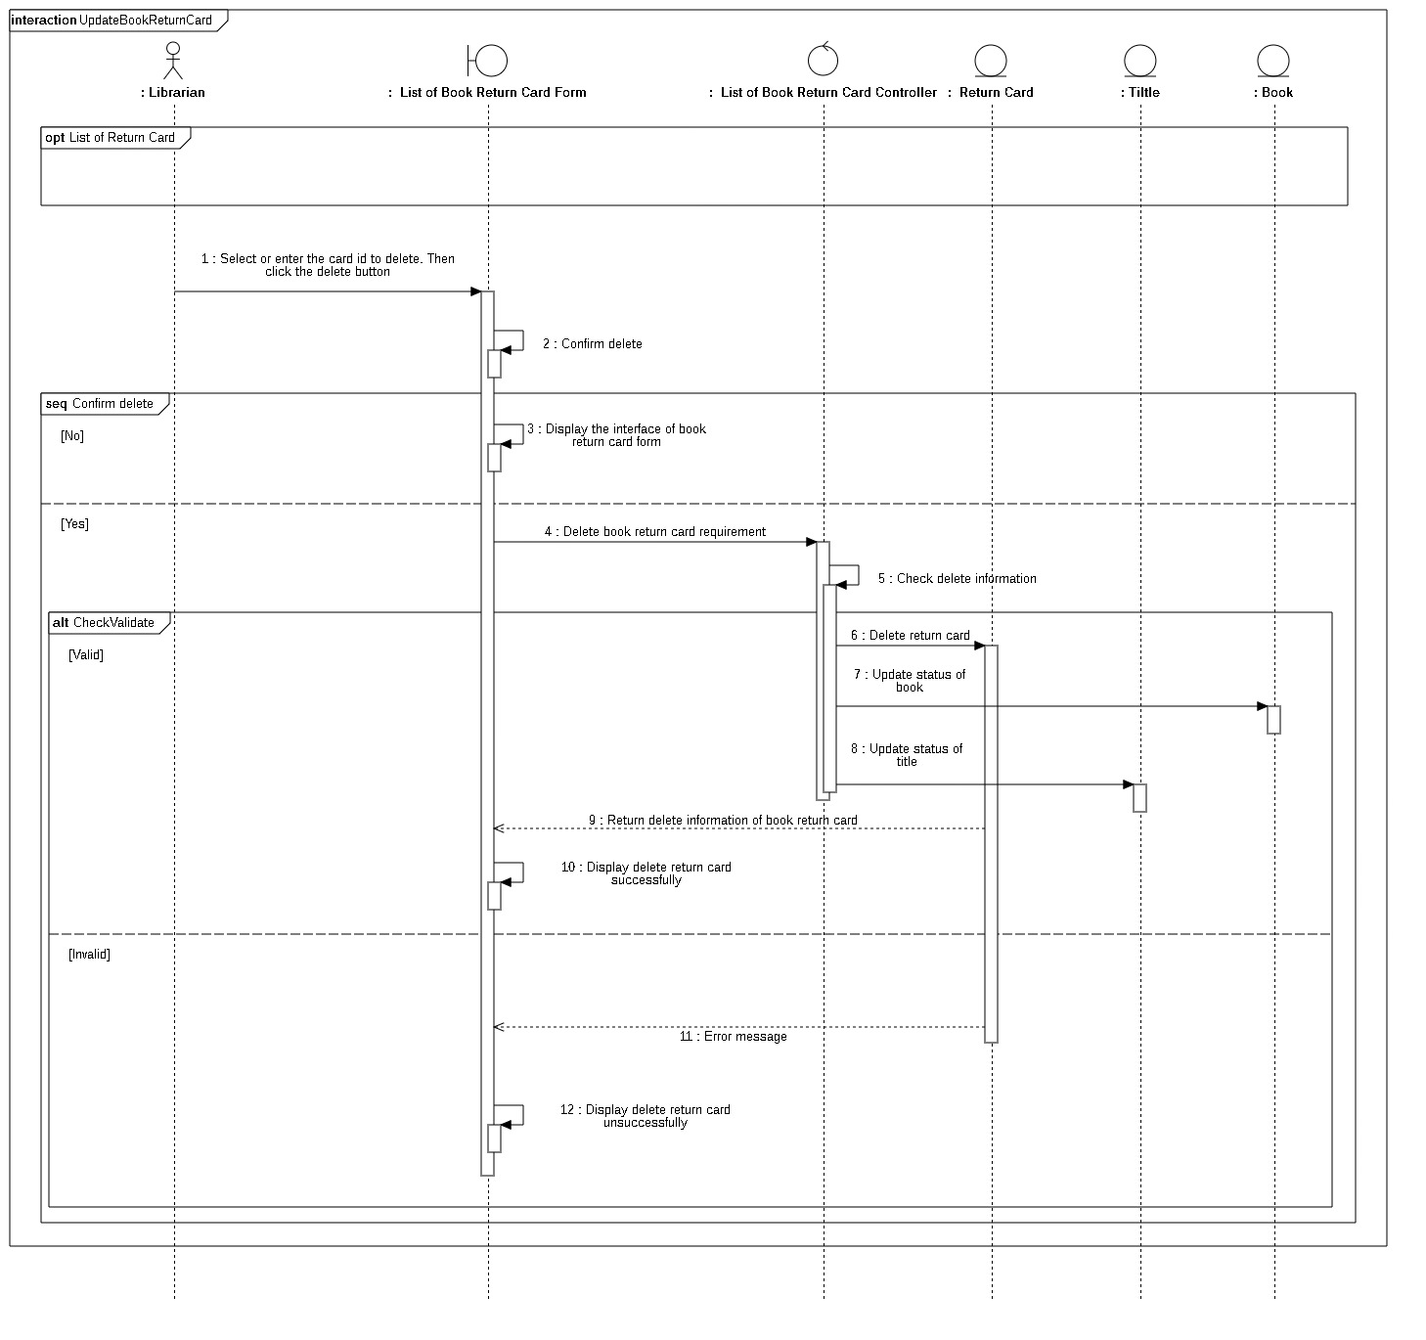

#### **3.6.6.4 Delete return card**

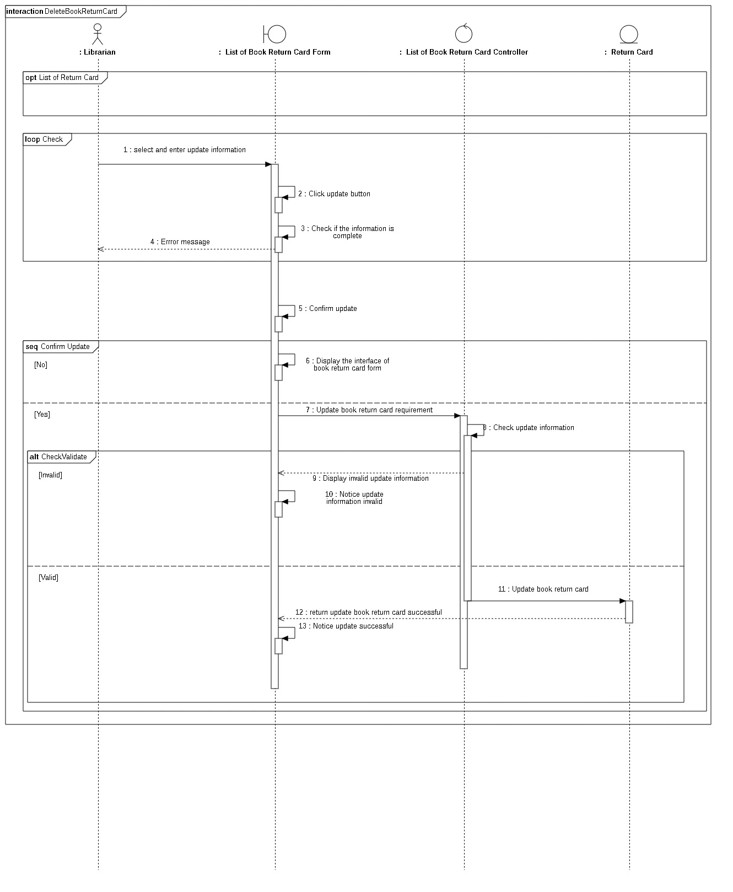

#### **Diagram Description automatically generated with medium confidence3.6.6.5 Search Return Card**

#### **3.6.6.6 Add Book Return Detail**

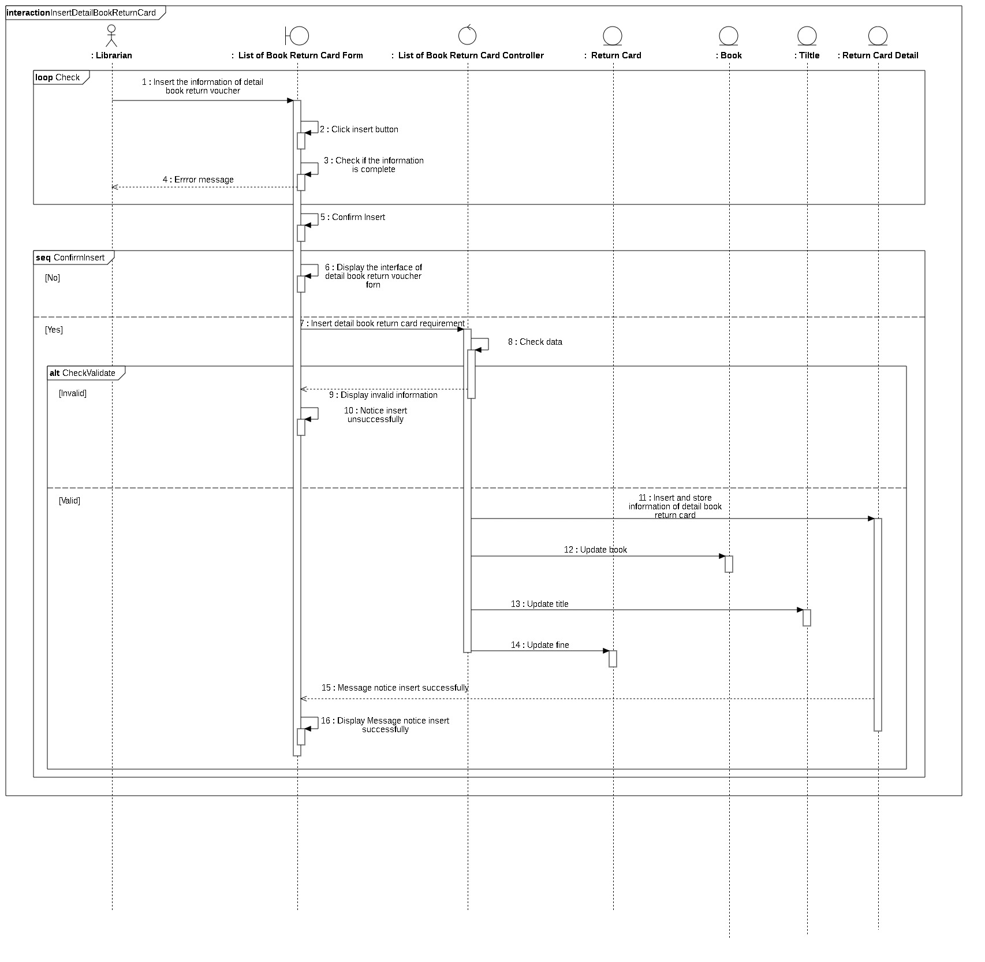

#### **3.6.6.7 Add Fines Receipts**

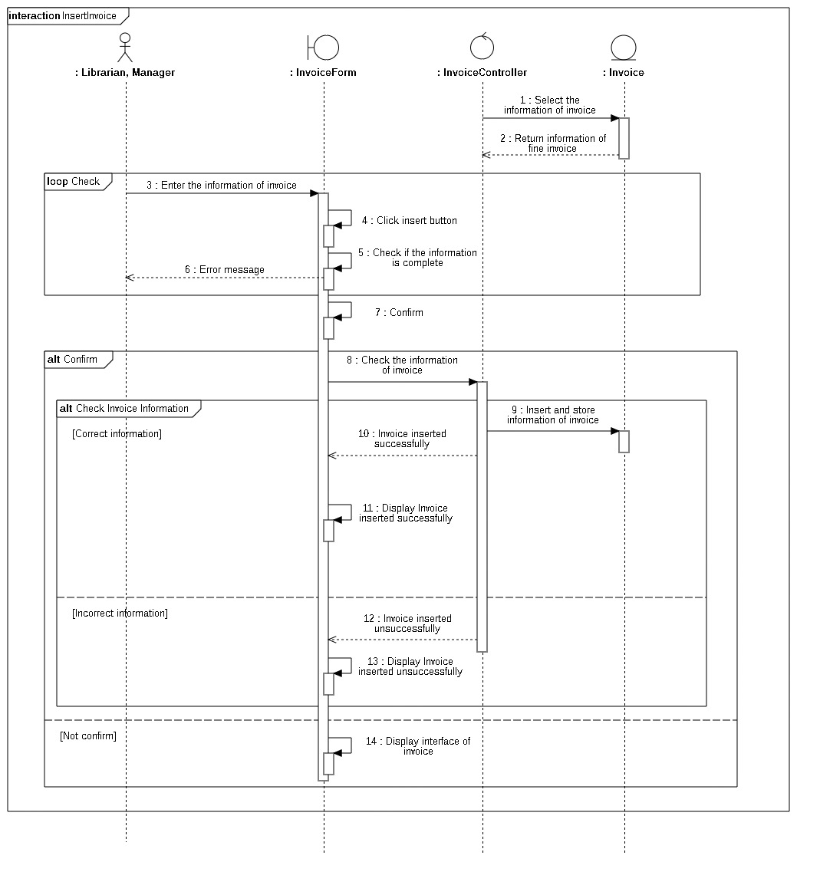

### **3.6.7 Statistic Report**

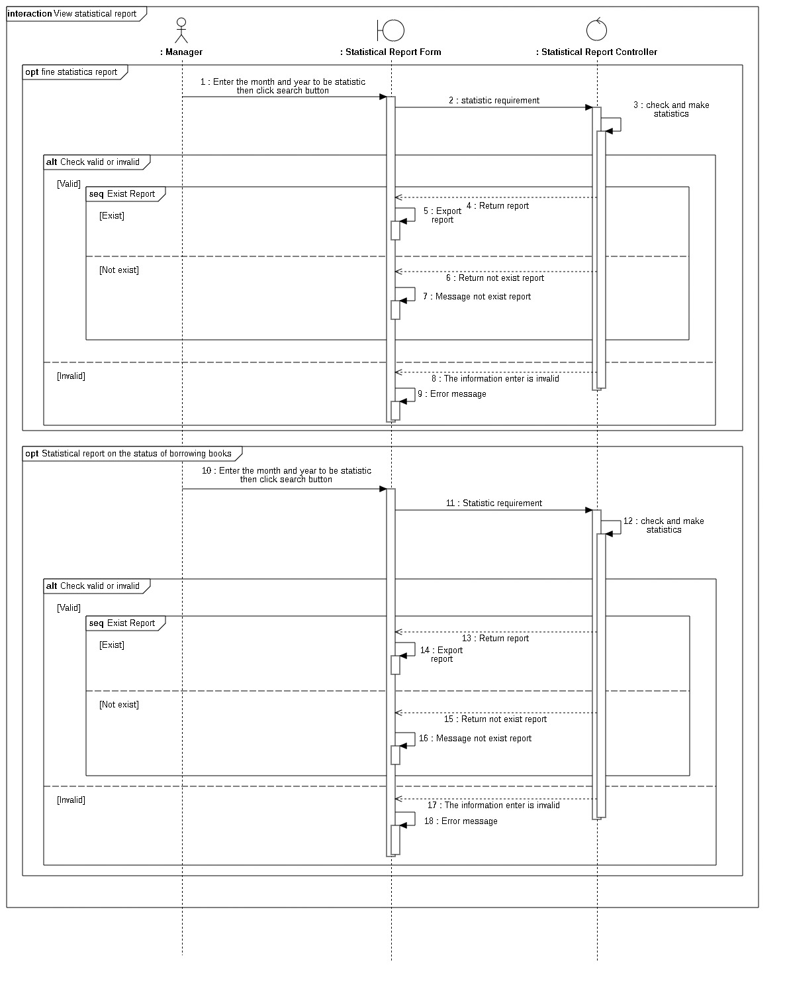

## **Class Diagram 3.7.1 Adminstrator overview class diagram**

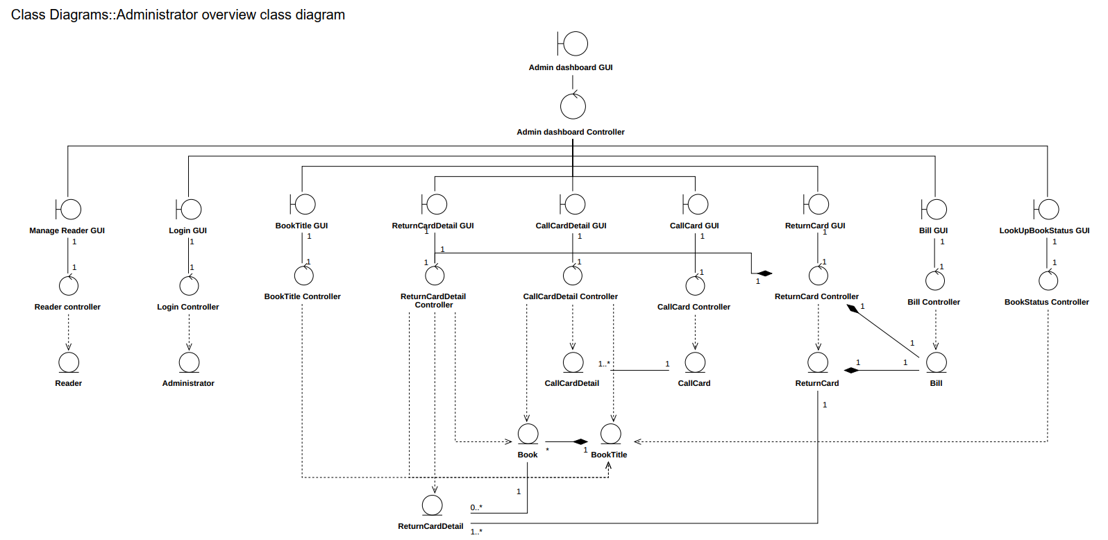

**3.7 Reader overview class diagram**

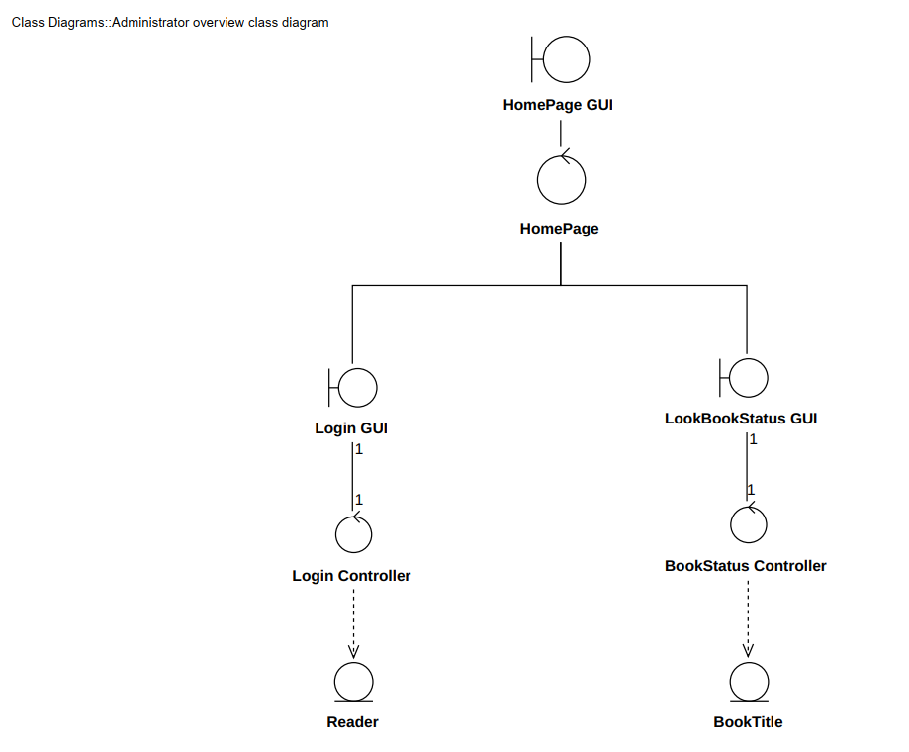

### **3.7.1 Class Login**

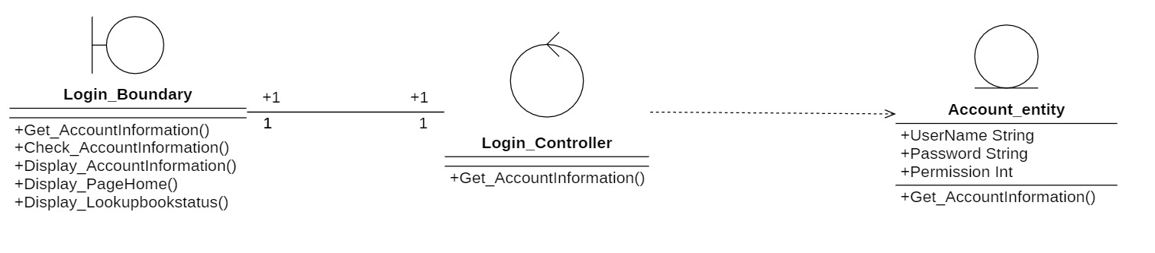

### **3.7.2 Class Look up book status**

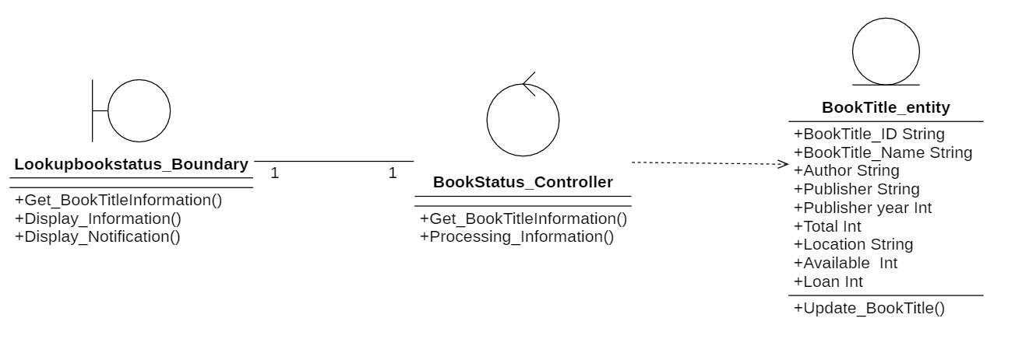

### **3.7.3 Class Manage Reader**

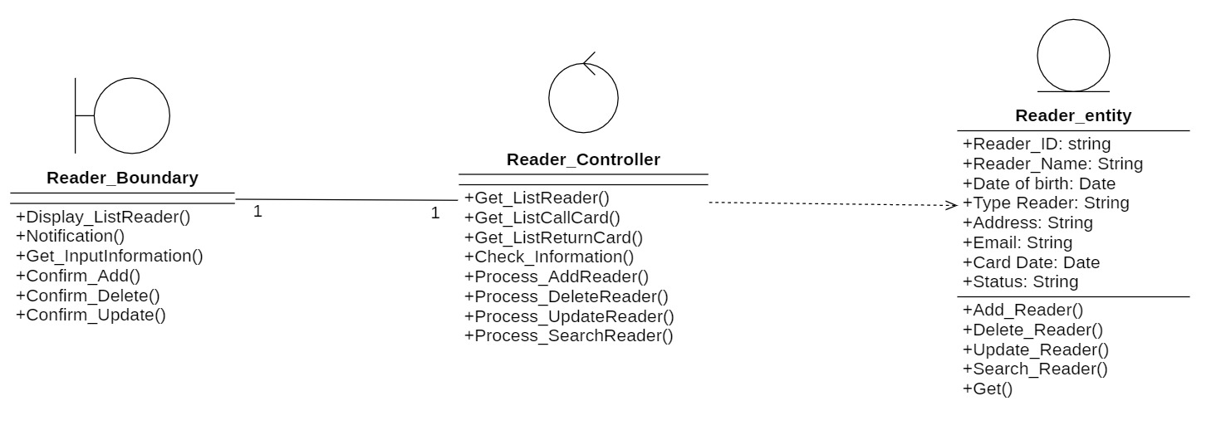

### **3.7.4 Class Manage Title**

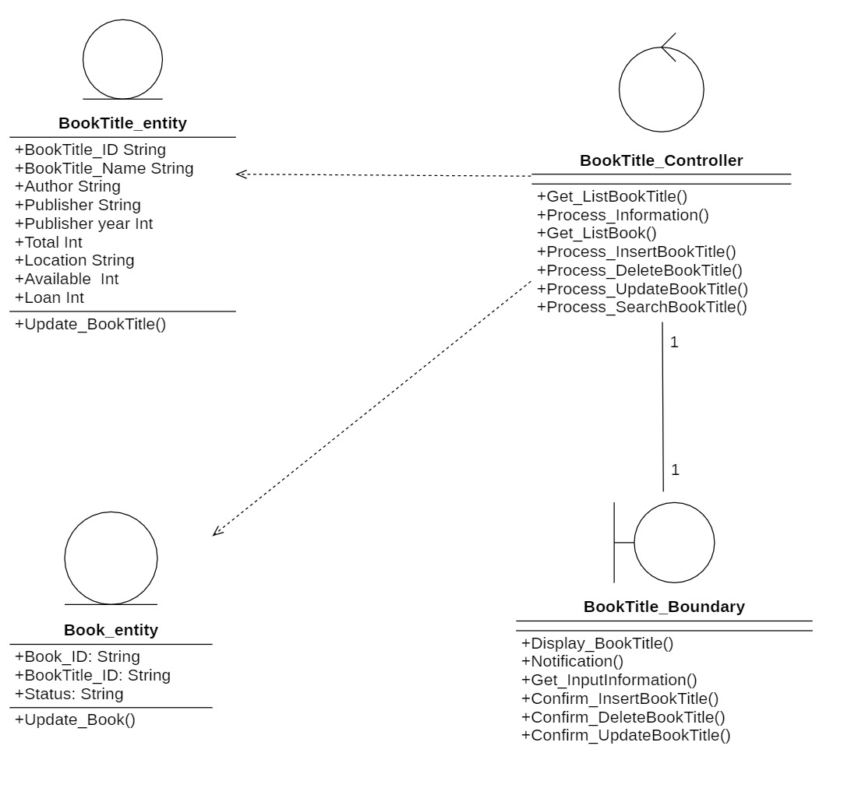

### **3.7.5 Class Manage the process of borrowing books**

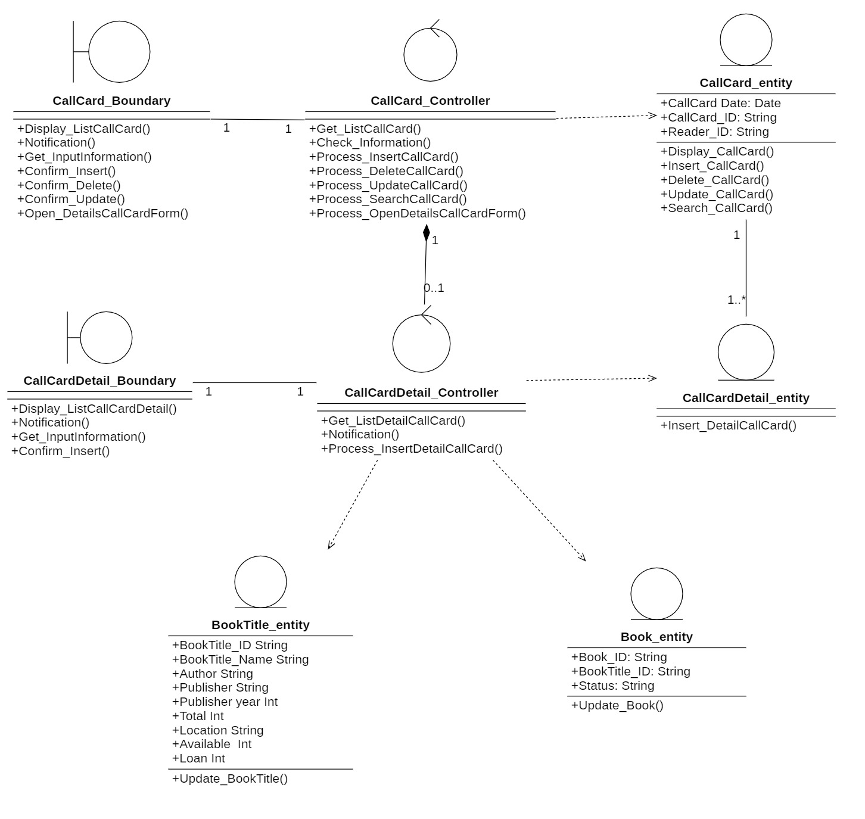

### **3.7.6 Class Manage the return Process**

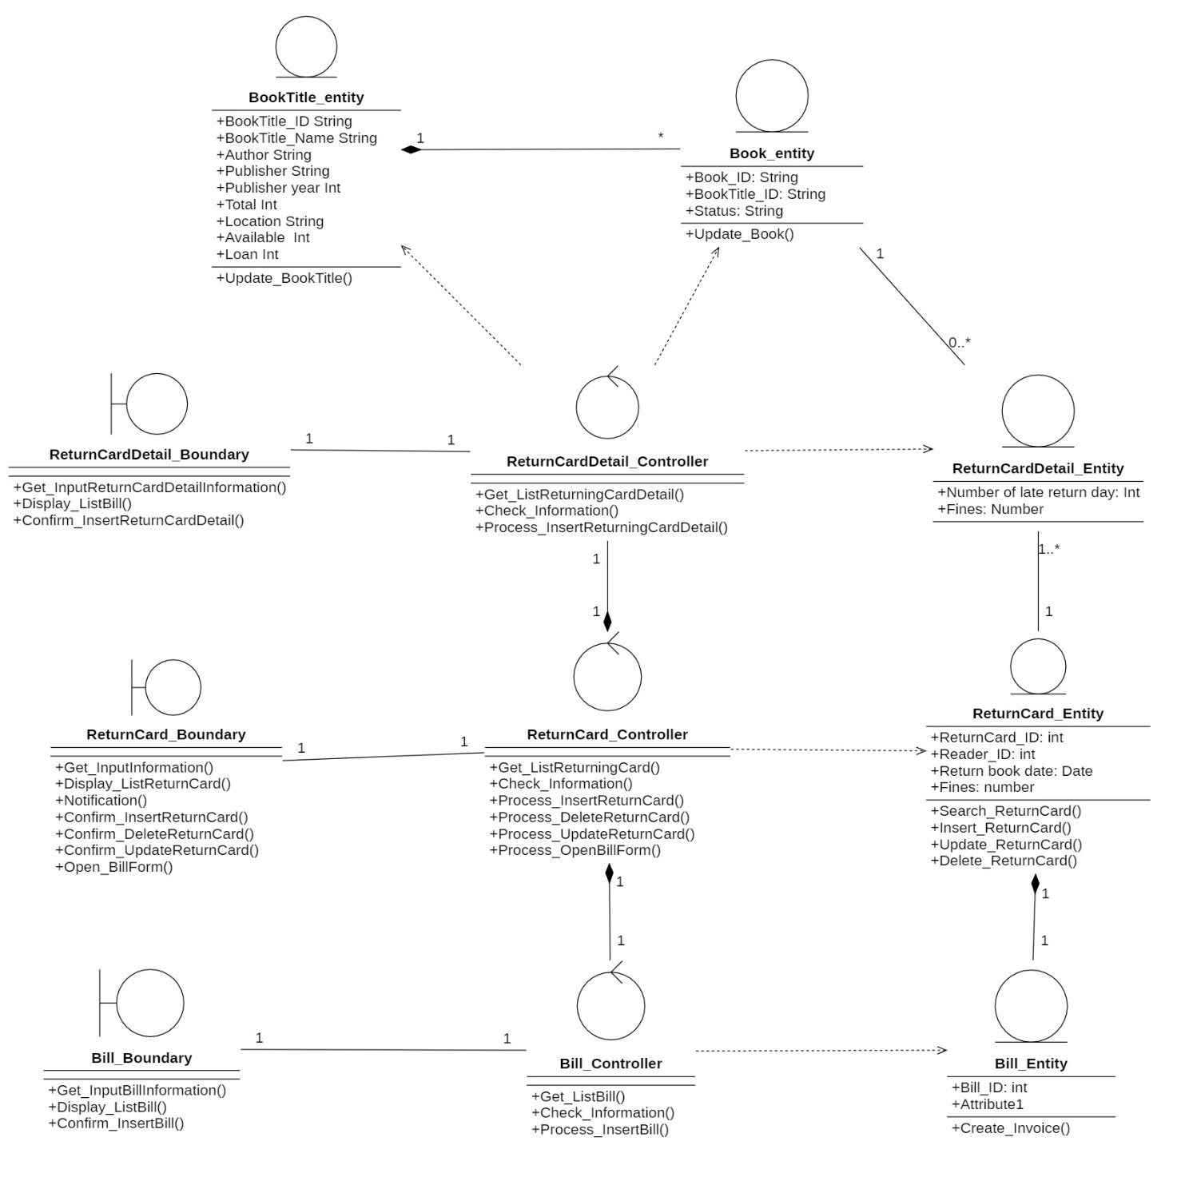

## **3.8 State Diagram**

## **3.9 Mapping to Relational Model from Entity class diagram**

**ERD diagram:**

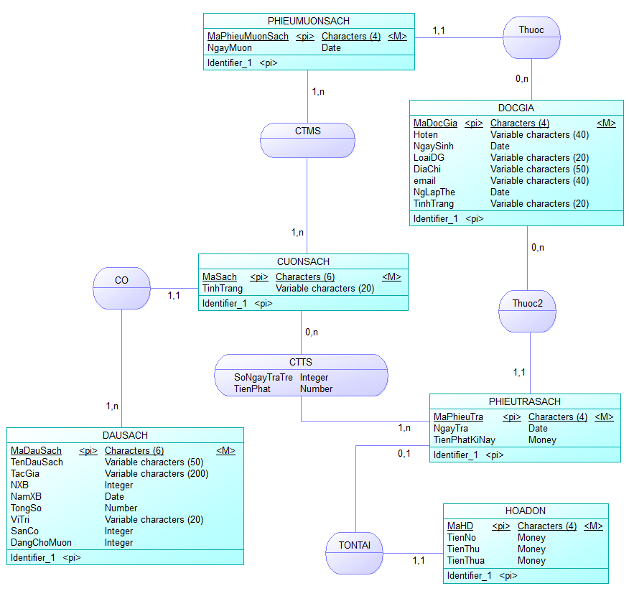

### **3.9.1 Description of ERD**

#### **3.1.2.1 Entity name: DOCGIA**

|  |  |  |  |  |
| --- | --- | --- | --- | --- |
| **DOCGIA** | | | |  |
| **STT** | **ATTRIBUTE** | **NAME** | **DATA TYPE** | **EXPLAIN** |
| 1 | Reader id | MaDocGia | char | Each reader has their own code. |
| 2 | Full name | Hoten | varchar | The reader's name. |
| 3 | Birthday | NgaySinh | date | The reader's birthday. |
| 4 | Reader type | LoaiDG | varchar | Reader type |
| 5 | Address | DiaChi | varchar | Reader's address |
| 6 | Email | Email | varchar | Reader's email |
| 7 | Create date | NgLapThe | date | Reader's card date |
| 8 | Condition | TinhTrang | Varchar | Reader card status |

#### **3.9.1.2 Entity name: DAUSACH**

|  |  |  |  |  |
| --- | --- | --- | --- | --- |
| **DAUSACH** | | | |  |
| **STT** | **ATTRIBUTE** | **NAME** | **DATA TYPE** | **EXPLAIN** |
| 1 | Tittle id | MaDauSach | char | Each book has its own id. |
| 2 | Tittle name | TenDauSach | varchar | Reader name |
| 3 | Author | TacGia | varchar | Reader id |
| 4 | Publisher | NXB | varchar | Publisher sách |
| 5 | Year of publication | NamXB | int | Year of publication sách |
| 6 | Amount | TongSo | number | Total number of titles |
| 7 | Location | ViTri | varchar | The location of the book. |
| 8 | Available | SanCo | int | Books are available. |
| 9 | On loan | DangChoMuon | int | The title of books are on loan. |

#### **3.9.1.3 Entity name: CUONSACH**

|  |  |  |  |  |
| --- | --- | --- | --- | --- |
| **CUONSACH** | | | |  |
| **STT** | **ATTRIBUTE** | **NAME** | **DATA TYPE** | **EXPLAIN** |
| 1 | Book id | MaSach | char | The id of the book |
| 2 | Tình trạng | TinhTrang | varchar | The status of the book. |

#### **3.9.1.4 Relation name: CTTS**

|  |  |  |  |  |
| --- | --- | --- | --- | --- |
| **CTTS** | | | |  |
| **STT** | **ATTRIBUTE** | **NAME** | **DATA TYPE** | **EXPLAIN** |
| 1 | Number of return days | SoNgayTraTre | int | The number of late return days of readers |
| 2 | Fine | TienPhat | number | Fine when readers return books late |

#### **3.9.1.5 Entity name: PHIEUMUONSACH**

|  |  |  |  |  |
| --- | --- | --- | --- | --- |
| **PHIEUMUONSACH** | | | |  |
| **STT** | **ATTRIBUTE** | **NAME** | **DATA TYPE** | **EXPLAIN** |
| 1 | Call card id | MaPhieuMuonSach | char | Id of call card |
| 2 | Borrow day | NgayMuon | date | Date borrow book |

#### **3.9.1.6 Entity name: PHIEUTRASACH**

|  |  |  |  |  |
| --- | --- | --- | --- | --- |
| **PHIEUTRASACH** | | | |  |
| **STT** | **ATTRIBUTE** | **NAME** | **DATA TYPE** | **EXPLAIN** |
| 1 | Returncard id | MaPhieuTra | char | Id of return card |
| 2 | Return day | NgayTra | date | Return day of reader |
| 3 | This term fine | TienPhatKiNay | money | This term fine of reader |

#### **3.9.1.7 Entity name: HOADON**

|  |  |  |  |  |
| --- | --- | --- | --- | --- |
| **HOADON** | | | |  |
| **STT** | **ATTRIBUTE** | **INITIALS OFF** | **DATA TYPE** | **EXPLAIN** |
| 1 | Invoice encryption | Mowing | char | Invoice code |
| 2 | Debt | TienNo | money | Readers' debt |
| 3 | Proceeds | TienThu | money | Librarian's money obtained from readers |
| 4 | Excess money | TienThua | money | Readers' excess money |

#### **3.9.1.8 Relation name: CTMS**

Name: CTMS

Description: Is a relation that shows what books to borrow from.

#### **3.9.1.9 Relation name: Thuoc2**

Name: Thuoc

Description: Is a relation that represents a book loan slip belonging to the reader.

#### **3.9.1.10 Name relation: Thuoc2**

Name: Thuoc2

Description: It is a relation that represents a return voucher that belongs to the reader.

#### **3.9.1.11 Relation name: Co**

Name: Co

Description: Is a relation that shows what books a book will have.

#### **3.9.1.12 Relation name: Tontai**

Name: Tontai

Description: As a relation showing a return voucher will exist more 1 1 turned out (penalty receipt).

### **3.9.2 Convert the ERD to a physical data model**

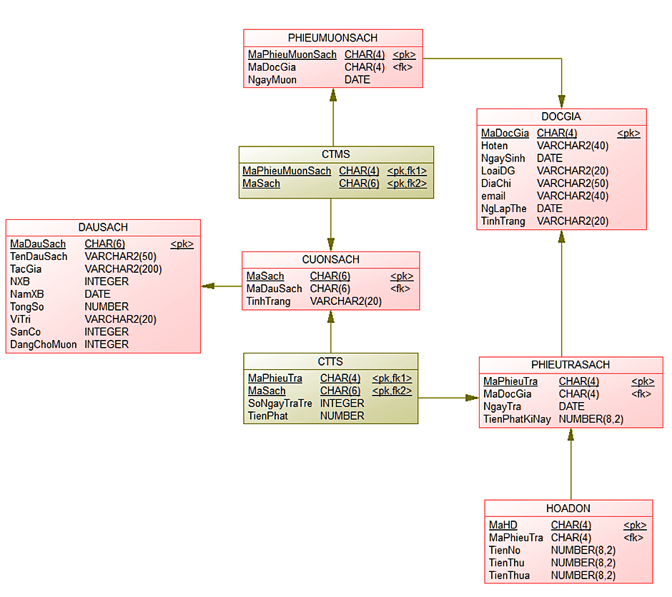

**Description table:**

#### **3.9.2.1 DAUSACH**

|  |  |  |  |  |  |  |
| --- | --- | --- | --- | --- | --- | --- |
| **STT** | **Attribute** | **Explain** | **Data type** | **Length** | **Range** | **Note** |
| 1 | MaDauSach | Book title id | char | 6 |  | Key |
| 2 | TenDauSach | Title name | varchar | 50 |  |  |
| 3 | TacGia | Author | varchar | 200 |  |  |
| 4 | NXB | Publisher | varchar |  |  |  |
| 5 | NamXB | Year of publication | int | 50 |  |  |
| 6 | TongSo | Amount | int |  |  |  |
| 7 | ViTri | Book location | varchar | 20 |  |  |
| 8 | SanCo | Available | int |  |  |  |
| 9 | DangChoMuon | On loan | int |  |  |  |

#### **3.9.2.2 CUONSACH**

|  |  |  |  |  |  |  |
| --- | --- | --- | --- | --- | --- | --- |
| **STT** | **Attribute** | **Explain** | **Data type** | **Length** | **Range** | **Note** |
| 1 | MaSach | Book id | char | 6 |  | Key |
| 2 | MaDauSach | Tittle id | char | 4 |  | Foreign key |
| 3 | TinhTrang | Status | varchar | 20 |  |  |

#### **3.9.2.3 DOCGIA**

|  |  |  |  |  |  |  |
| --- | --- | --- | --- | --- | --- | --- |
| **STT** | **Attribute** | **Explain** | **Data type** | **Length** | **Range** | **Note** |
| 1 | MaDocGia | Reader id | char | 4 |  | Key |
| 2 | HoTen | Reader name | varchar | 40 |  |  |
| 3 | LoaiDG | Reader type | varchar | 10 |  |  |
| 4 | NgaySinh | Birthday | date |  |  |  |
| 5 | DiaChi | Address | varchar | 50 |  |  |
| 6 | Email | Email | varchar | 50 |  | The end is @gmail.com |
| 7 | NgLapthe | Create date | date |  |  | Create date lơn hơn Birthday |
| 8 | TinhTrang | Reader card status | varchar | 20 |  | Limited|| Expired |

#### **3.9.2.4 PHIEUMUONSACH**

|  |  |  |  |  |  |  |
| --- | --- | --- | --- | --- | --- | --- |
| **STT** | **Attribute** | **Explain** | **Data type** | **Length** | **Range** | **Note** |
| 1 | MaPhieuMuonSach | Call card id | char | 4 |  | Key |
| 2 | MaDocGia | Reader id | char | 4 |  | Foreign key |
| 3 | NgayMuon | Date borrow book | date |  |  | Borrowed date is bigger than Create date |

#### **3.9.2.5 CTMS**

|  |  |  |  |  |  |  |
| --- | --- | --- | --- | --- | --- | --- |
| **STT** | **Attribute** | **Explain** | **Data type** | **Length** | **Range** | **Note** |
| 1 | MaPhieuMuonSach | Call card id | char | 4 |  | Key, Foreign key |
| 2 | MaSach | Book id | char | 4 |  | Key, Foreign key |

#### **3.9.2.6 PHIEUTRASACH**

|  |  |  |  |  |  |  |
| --- | --- | --- | --- | --- | --- | --- |
| **STT** | **Attribute** | **Explain** | **Data type** | **Length** | **Range** | **Note** |
| 1 | MaPhieuTra | Call card id | char | 4 |  | Key |
| 2 | MaDocGia | Reader id | char | 4 |  | Foreign key |
| 3 | NgayTra | Book return day | date |  |  | The return day is greater than the loan date. |
| 4 | TienPhatKyNay | This term fine | money |  |  |  |

#### **3.9.2.7 CTTS**

|  |  |  |  |  |  |  |
| --- | --- | --- | --- | --- | --- | --- |
| **STT** | **Attribute** | **Explain** | **Data type** | **Length** | **Range** | **Note** |
| 1 | MaPhieuTra | Return card id | char | 4 |  | Key, Foreign key |
| 2 | MaSach | Book id | char | 4 |  | Key, Foreign key |
| 3 | SoNgayTraTre | Number of late return days | int |  |  |  |
| 4 | TienPhat | Fine | money |  |  |  |

#### **3.9.2.8 HOADON**

|  |  |  |  |  |  |  |
| --- | --- | --- | --- | --- | --- | --- |
| **STT** | **Attribute** | **Explain** | **Data type** | **Length** | **Range** | **Note** |
| 1 | MaHD | Invoice id | char | 4 |  | Key |
| 2 | MaPhieuTra | Return card id | char | 4 |  | Foreign key |
| 3 | TienNo | Debt | money |  |  |  |
| 4 | TienThu | Proceeds | money |  |  |  |
| 5 | TienThua | Excess money | money |  |  |  |

# **CHAPTER 4: IMPLEMENTATION AND TESTING**

### **4.1 Development environment**

* Operating system: Window 10
* Database: Oracle database
* Text Editor: Netbeans

### **4.2 List of screens**

### **4.2.1 Login**

|  |  |  |
| --- | --- | --- |
| STT | Screens | Function |
| 1 | Login | Login |

### **4.2.2 Library management**

|  |  |  |
| --- | --- | --- |
| STT | Screen | Function |
| 1 | Manage Reader | Display list Reader  Enter and view reader information.  Contains related options. |
| 2 | Manage Title | Display list Title.  Enter and view Title information.  Contains related options.. |
| 3 | Book information | Display list Book.  Enter and view Book information.  Contains related options. |
| 4 | Call Card | Display list Call Card.  Enter and view Call Card information.  Contains related options. |
| 5 | Call Card Detail | Display list of books to borrow  Enter and view information.  Contains related options. |
| 6 | Return Card | Display list Return Card.  Enter and view Return Card information.  Contains related options. |
| 7 | Return Card Detail | Display list of books to return  Enter and view information  Containts related options. |
| 8 | Invoice | Display list invoice.  Enter and view Invoice information.  Containts related options. |
| 9 | Statistic Report | Cho phép chọn loại hình muốn thống kê, và nhập tháng, năm cần thống kê. |

## **4.3 Description of screens**

### **4.3.1 Login**

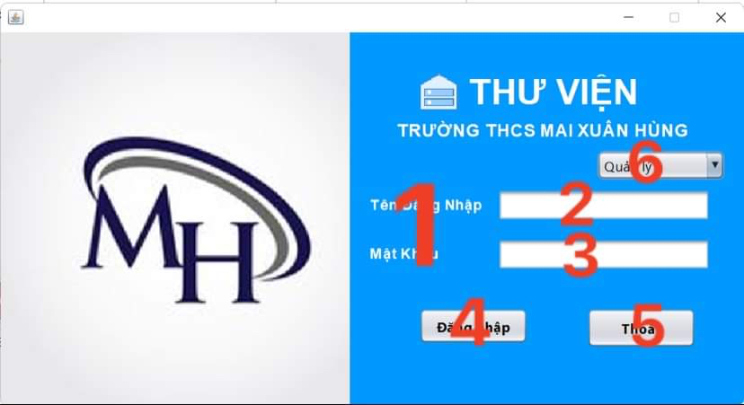

|  |  |  |  |
| --- | --- | --- | --- |
| STT | Name | Type | Function |
| 1 | Username  Password | Label | Display information |
| 2 | Empty frame | Textfield | Enter information compatible with the label Username |
| 3 | Empty frame | JPasswordField | Enter information compatible with the label Password |
| 4 | Login | Button | Click to login |
| 5 | Exit | Button | Click to confirm exit |
| 6 | Login form selection box | Combobox | Click to choose a login form: Manager, Librarian, Reader |

### **4.3.2 Library management**

#### **4.3.2.1 Manage Reader**

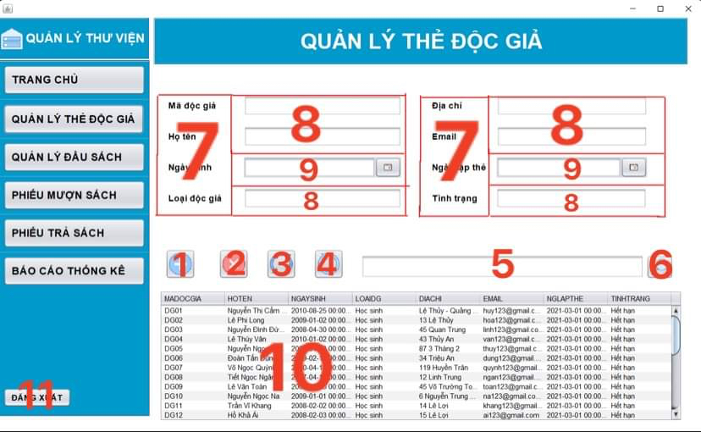

|  |  |  |  |
| --- | --- | --- | --- |
| STT | Name | Type | Function |
| 1 | Insert Reader | Button | Click to add reader information |
| 2 | Delete Reader | Button | Click to delete reader information |
| 3 | Update Reader information | Button | Click to update reader information |
| 4 | Refresh | Button | Click to refresh the page |
| 5 | Search box | Textfield | Enter information readers need to search |
| 6 | Search box | Button | Click to search |
| 7 | Reader id  Full name  Birthday  Reader type  Address  Email  Card date set-up date  Condition | Label | Display information |
| 8 | Empty frame | Textfield | Import into the same information with label before that. |
| 9 | Empty frame | JDateChooser | Select content |
| 10 | Reader table | JTable | Table display the information of reader |
| 11 | Log out | Button | Click to log out |

#### **4.3.2.2 Manage Title**

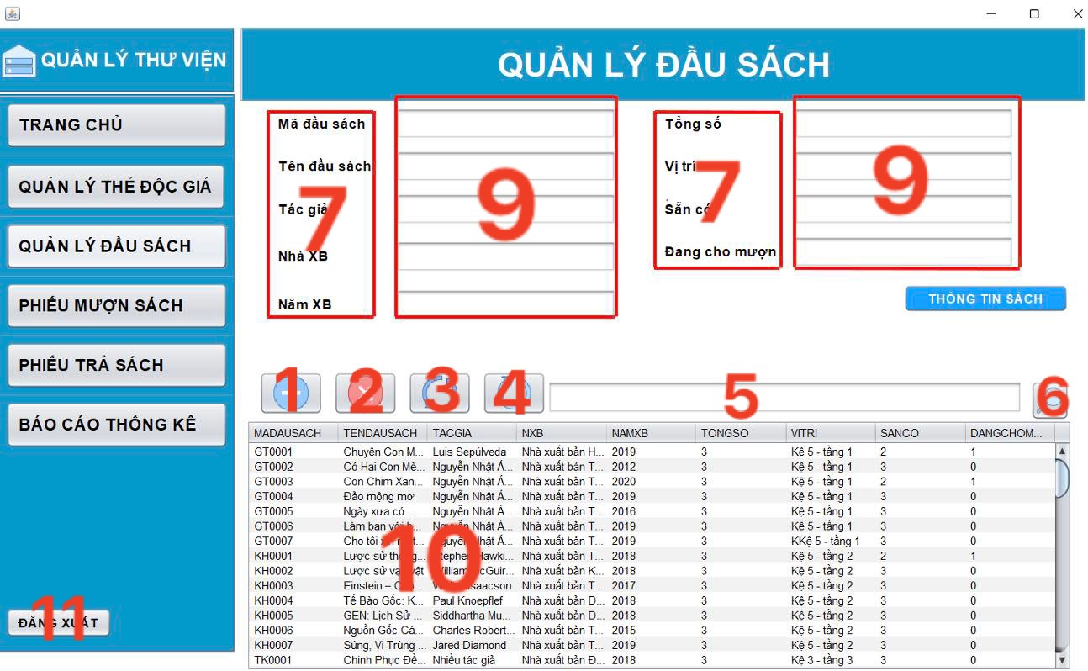

|  |  |  |  |
| --- | --- | --- | --- |
| STT | Name | Type | Function |
| 1 | Insert Title | Button | Click to insert Title information |
| 2 | Delete Title | Button | Click to delete Title information |
| 3 | Update Title information | Button | Click to update Title information |
| 4 | Refresh | Button | Click to refresh the page |
| 5 | Search box | Textfield | Enter the title of the book you want to search |
| 6 | Search button | Button | Click to search |
| 7 | Book information | Button | Click to view book information |
| 8 | Book title id  Title name  Author  HouseX  YearX  Amount  Location  Available  On loan | Label | Display information |
| 9 | Empty frame | Textfield | Import into the same information with label before that. |
| 10 | Table Title | JTable | Table display Title information |
| 11 | Log out | Button | Click to log out |

#### **4.3.2.3 Book information**

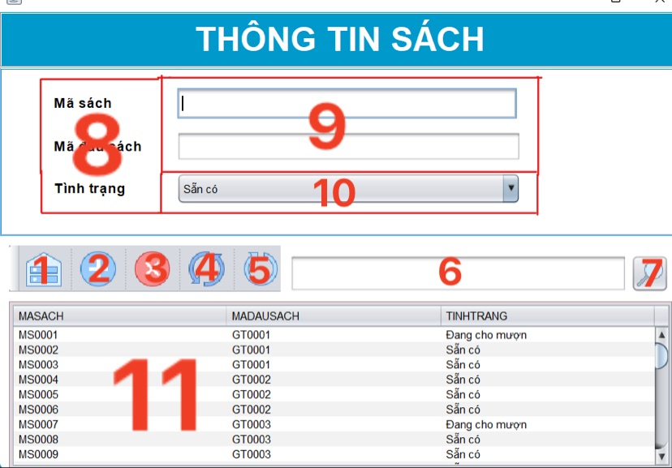

|  |  |  |  |
| --- | --- | --- | --- |
| STT | Name | Type | Function |
| 1 | Back button | Button | Return to the title management interface |
| 2 | Insert Book | Button | Click to insert book information |
| 3 | Delete Book | Button | Click to delete book information |
| 4 | Update Book information | Button | Click to Update book information |
| 5 | Refresh | Button | Click to refresh the page |
| 6 | Search box | Textfield | Enter information about the book you want to search |
| 7 | Search button | Button | Click to search |
| 8 | Book id  Book title code  Condition | Label | Display information |
| 9 | Empty frame | Textfield | Enter information that is compatible with the previous label. |
| 10 | Empty frame | Combobox | Select content |
| 11 | Table book | JTable | Table dislay list book information |

#### **4.3.2.4 Manage Call Card**

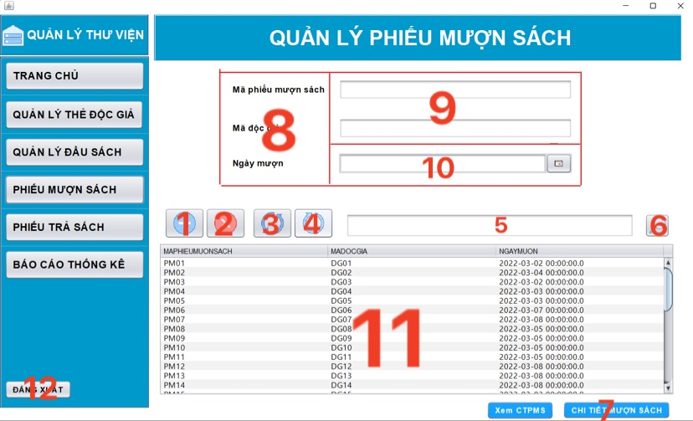

|  |  |  |  |
| --- | --- | --- | --- |
| STT | Name | Type | Function |
| 1 | Insert Call Card | Button | Click to Insert Call Card information |
| 2 | Delete Call Card | Button | Click to Delete Call Card information |
| 3 | Update Call Card information | Button | Click to Update Call Card information |
| 4 | Refresh | Button | Click to refresh the page |
| 5 | Search box | Textfield | Enter the information on the loan voucher you need to search |
| 6 | Search button | Button | Click to search |
| 7 | Call Card Detail | Button | Click to display call card detail |
| 8 | Book borrow card id  Reader code  Borrow date  Book code | Label | Display information |
| 9 | Empty frame | Textfield | Import into the same information with label before that. |
| 10 | Empty frame | JDateChooser | Select content |
| 11 | Table call card | JTable | Table display list Call card information |

#### **4.3.2.5 Call Card Detail**

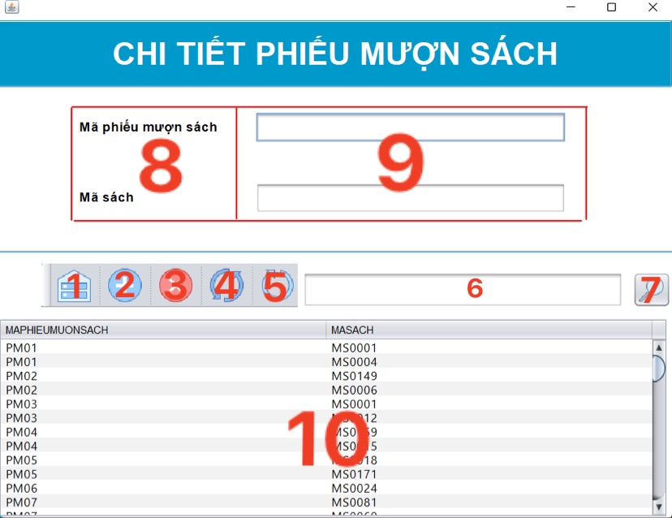

|  |  |  |  |
| --- | --- | --- | --- |
| STT | Name | Type | Function |
| 1 | Back Button | Button | Return to the call card interface |
| 2 | Insert Call Card Detail | Button | Click to insert call card detail information |
| 3 | Delete Call Card Detail | Button | Click to delete call card detail information |
| 4 | Refresh | Button | Click to refresh the page |
| 5 | Search box | Textfield | Enter the details |
| 6 | Search button | Button | Click to search |
| 7 | Book loan coupon id  Book id | Label | Display informatin |
| 8 | Empty frame | Textfield | Enter information that is compatible with the previous label. |
| 9 | Table Call Card Detail | JTable | Table display list call card detail |

#### **4.3.2.6 Manage Return Card**

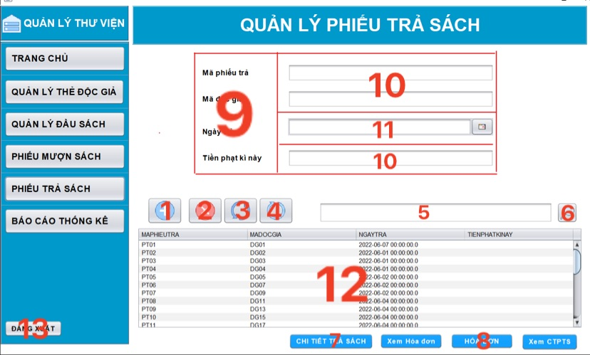

|  |  |  |  |
| --- | --- | --- | --- |
| STT | Name | Type | Function |
| 1 | Insert Return Card | Button | Click to Insert Return Card information |
| 2 | Delete Return Card | Button | Click to Delete Return Card information |
| 3 | Update Return Card information | Button | Click to Update Return Card information |
| 4 | Refresh | Button | Click to refresh the page |
| 5 | Search box | Textfield | Enter the information on the loan voucher you need to search |
| 6 | Search button | Button | Click to search |
| 7 | Return Card Detail | Button | Click to display Return card detail |
| 8 | Invoice button | Button | Click to view invoice details |
| 9 | Book return voucher code  Reader code  Payday  This term fine | Label | Display information |
| 10 | Empty frame | Textfield | Import into the same information with label before that. |
| 11 | Empty frame | JDateChooser | Select content |
| 12 | Table Return Card | JTable | Table display list Call card information |
| 13 | Log out | Button | Click to Log out |

#### **4.3.2.7 Return Card Detail**

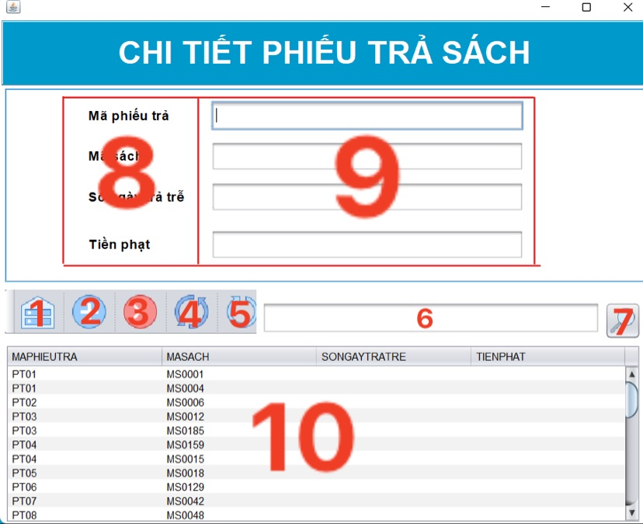

|  |  |  |  |
| --- | --- | --- | --- |
| STT | Name | Type | Function |
| 1 | Back Button | Button | Return to the return card interface |
| 2 | Insert Call Return Detail | Button | Click to insert return card detail information |
| 3 | Delete Return Card Detail | Button | Click to delete returm card detail information |
| 4 | Update Return Card detail | Button | Click to refresh the page |
| 5 | Refresh | Button | Enter the details |
| 6 | Search box | Textfield | Click to search |
| 7 | Search button | Button | Display informatin |
| 8 | Pay slip code  Book code  Number of late payment days  Fine | Label | Enter information that is compatible with the previous label. |
| 9 | Empty frame | Textfield | Table display list return card detail |
| 10 | Table return card detail | JTable | Return to the return card interface |

#### **4.3.2.8 Invoice**

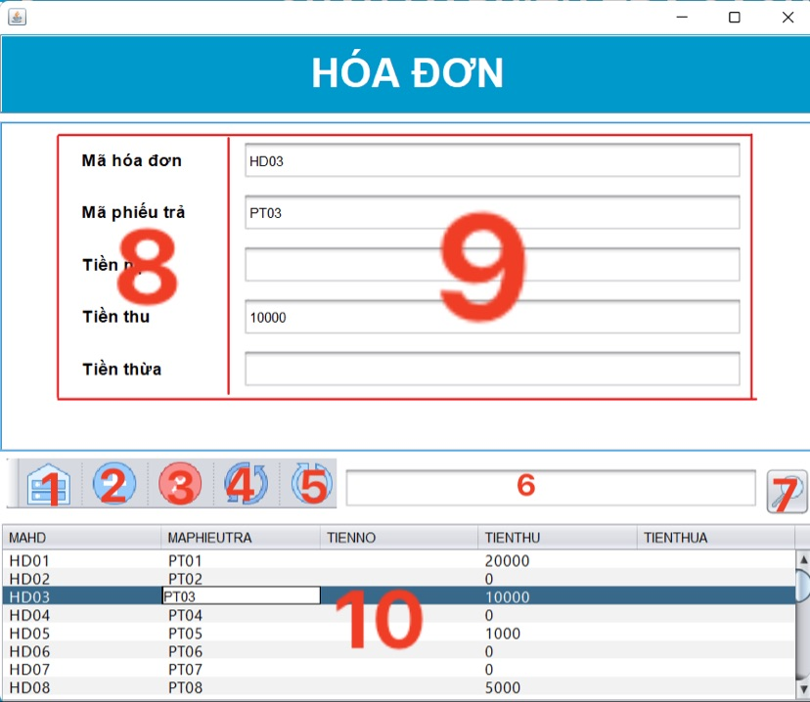

|  |  |  |  |
| --- | --- | --- | --- |
| STT | Name | Type | Function |
| 1 | Back button | Button | Return to the return card interface |
| 2 | Insert Invoice | Button | Click to insert invoice information |
| 3 | Delete Invoice | Button | Click to delete invoice information |
| 4 | Update Invoice information | Button | Click to update invoice information |
| 5 | Refresh | Button | Click to refresh the page |
| 6 | Search box | Textfield | Enter the invoice information you want to search |
| 7 | Search button | Button | Click to search |
| 8 | Invoice encryption  Pay slip code  Debt  Proceeds  Excess money | Label | Display information |
| 9 | Empty frame | Textfield | Enter information that is compatible with the previous label. |
| 10 | Table Invoice | JTable | Table display list invoice information |

#### **4.3.2.9 Statistic report**

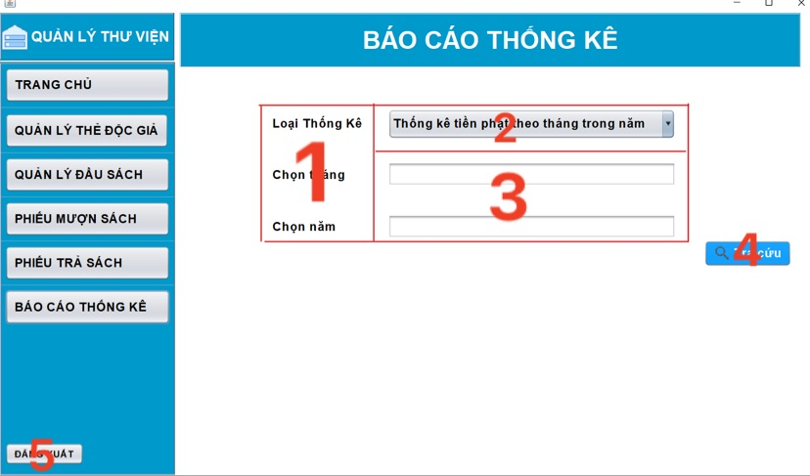

|  |  |  |  |
| --- | --- | --- | --- |
| STT | Name | Type | Function |
| 1 | Statistical type  Select a month  Select five | Label | Display information |
| 2 | Report Type | Combobox | Select content |
| 3 | Empty frame | Textfield | Enter information that is compatible with the previous label. |
| 4 | Search | Button | Click to search |
| 5 | Log out | Button | Click to log out |

# **CHAPTER 5 – CONCLUSION**

## **5.1 Results achieved**

Managing libraries using information systems is not a new direction.

However, there are still a lot of small library facilities managed only manually. Realize that this is a good and practical topic that can be widely applied. Therefore, the authors decided to choose the topic of creating a library management system that helps to manage simpler, more convenient and reduce the workload manually.

Understand and apply the knowledge of information system design analysis, specifically do designs such as:

1. Modeling is required.
2. The design is used case.
3. Designed by Activity Diagram.
4. The design is sequence diagram.
5. Designed by Class Diagram.
6. Analyze the fierce composition of the project.

Build "Library Management" software with the following functions:

* Login
* Reader Management
* Manage Books (including Book Management)
* Book Loan Voucher Management (including CTMS Management)
* Management of book return vouchers (including management of CTTS, Billing of fine collection)
* Manage Book Status Lookup
* Statistical report

Understanding how to build the interface using JavaSwing, the design is reported on JasperReport.

Know how to analyze, design a small project.

Master the skills of division of work, time arrangement, teamwork, communication skills.

## **5.2 Restrict**

Due to the short time plus the initial work requirements are quite large, in the process of implementing the project the group also encounters some limitations:

1. Because of the construction of the interface on the JavaSwing platform, the interface has not been attentive.
2. The designs are flawed.
3. The division of work is uneven.
4. It is not possible to fully perform the original functions.
5. The program runs slowly because the source code is not optimal.
6. There are differences between design theory and programming.

The new members only know the basics of system design analysis, not yet grasp the advanced part.

## **5.3 Lessons learned:**

Although the project has gone according to plan, in the development process, there are still some unforeseen problems that cannot be avoided such as: unexpected jobs, disagreements on how to write code due to not being able to deliver unified text.

Acquire new important knowledge about programming, gain experience in project management activities.

## **5.4 Evaluation of project results:**

The project is in the final stage, the implementation is close to the previous plan

Project costs increase compared to the plan but not significantly, need to control costs better not to repeat the situation of generating additional costs

## **5.5 Direction of development:**

To overcome existing limitations as well as develop team software there are a number of suggestions as follows:

1. Use more modern technologies to build management software.
2. Add book loan slips, as well as print fine receipts.
3. Add some integrity constraints so that the system works more accurately.
4. Add book reservations, register readers' cards, renew documents, and request additional documents.
5. Upgrading the interface system is more user-friendly, limiting too much entry to avoid mistakes.

# **REFERENCES:**

1. Slide subject Analysis and Design of Information Systems - Faculty of Information Technology – VNU.

2. Syllabus on Analysis and Design of Information Systems - Compilation: Dr. Cao Thi Nhan (Editor), MSc. Nguyen Dinh Loan Phuong.

3. Reference projects: Library management, Customer management at English center, LS Park amusement park management.

4. Java/ JavaSwing reference: Java Tutorial (w3schools.com), Java Tutorial – Tutorialspoint.

5. Youtube: [How to Make a UML Sequence Diagram - YouTube](https://www.youtube.com/watch?v=pCK6prSq8aw)

# **The end.**